Aditya Nag

Ben Weidman

Gina Upperman

May 4, 2006

Elec 493

Final Design Documentation Package

Developing Sensor Networks:

A Testbed for Distributed Data Compression and Signal Processing

Table of Contents

Introduction …………………………………………………………………………. 3

Background and Research …………………………………………………………… 4

Existing Technologies ……………………………………………………………….. 6

Project Description and Specifications ……………………………………………… 7

Description of Design ………………………………………………………………... 9

Summary and Conclusions ………………………………………………………….. 21

Appendices:

Team Roster ………………………………………………………………... 22

Engineering Drawings ………………………………………………………. 23

Program Listings (nesC code) ………………………………………………. 24

Vendors …..…………………………………………………………………. 72

Budget ………………………………………….…………………………… 72

Supporting Calculations …………………………………………………….. 72

Bibliography ……………………………………………………..….………. 74

Introduction

A sensor network is a collection of nodes (called sensor motes) that are capable of taking a comprehensive set of data measurements, processing the data, and transmitting raw or processed data to other nodes in the network. Each mote includes a sensor board with an array of sensing functions, a radio transceiver, an embedded processor, and an onboard power supply. The motes collect and process data which is then sent via one or more communication “hops” to a central data sink node. Due to their low cost and flexible deployment, these sensor motes are especially well-suited for applications that measure changing patterns in environmental conditions over time, such as tracking pollution levels, regulating irrigation on a farm, or monitoring natural disasters. However, sensor networks inherently face three major design challenges: hardware and software limitations, communication issues, and battery lifetime. In order for sensor networks to be a viable solution, these challenges need to be addressed.

The purpose of our project was to design and deploy a functional sensor network in Duncan Hall which met certain standards of accuracy and energy efficiency. This network recorded data measurements of light and temperature for several days and transmitted these measurements from various locations in our testing area to one sink node which then forwarded the information to a computer to be analyzed. Our network deployment effectively detected variations and trends in light and temperature over time. After deploying a basic functional test of this network, we further explored the effects of taking an in-network wavelet transform on the data. This should lay a basic foundation for future groups who wish to explore different algorithms for local processing or compressed sensing to improve battery performance.

Background and Research

A sensor network is a collection of sensor motes with measurement, communication, and processing capabilities. Individual motes take measurements of environmental conditions, such as light and temperature, and transmit processed information to a central data sink. Sensor networks automate the measurement process and provide a very comprehensive set of readings, allowing for detailed processing and analysis of the measurements.

Applications and Benefits

Sensor network applications include analyzing changing patterns in environmental conditions over time. A sensor network can consist of hundreds of motes that use multi-hop communication spread out over a large geographical area. For example, a sensor network with motes extending across a city can track pollution levels. It can be used to regulate conditions on a farm such as irrigation levels. Additionally, it can be used for the monitoring of large-scale natural disasters, such as wildfires or volcanoes.

Conventional monitoring systems like the National Weather Service’s network of weather stations are time-consuming to install and maintain. A big advantage of using a sensor network instead is that it can automate the measurement process: ideally, once it is deployed, it can take measurements and process the data automatically. Additionally, a network of battery-powered wireless sensor nodes can be deployed quickly in response to a crisis; whereas, traditional measurement stations cannot. For example, a plane can fly over a natural disaster area, where people should not go, and drop sensors that could then report about the disaster conditions. In addition to being more flexible, the deployment of wireless sensor networks is also cheaper than that of conventional systems. In short, a wireless sensor network can make possible the large-scale, on-demand tracking and monitoring of many physical processes over large areas [1].

Hardware/ Software Issues

An inherent difficulty in wireless sensor networks is the constraint on hardware and software resources on the motes. Due to their small size, theses motes have limited processing capabilities. For example, they have a very small amount of onboard memory (4KB RAM and 128 KB program flash). Another difficulty is that much of the software for wireless sensor networks consists of an open source work-in-progress. In our case, the motes were programmed with the TinyOS operating system [2]. The underlying networking protocol that was supposed to be in place for basic communication functionality was underdeveloped. For example, we had to develop our own code for nodes to be able to send and receive multiple messages at the same time. Lack of an efficient MAC communication layer was a large problem we were unable to tackle. In addition, incomplete library files, limited documentation, and inconsistent code standards all added complications to the deployment of the sensor network.

Communication Issues

A second major challenge with sensor networks is the inherent unreliability of wireless communication. Transmission decays beyond a certain distance and physical obstructions present a major threat to transmission reliability. Our project uses “Micaz” motes from Crossbow Technology [3]. The antenna on these motes is a 2.4 GHz Transceiver that transmits data at a rate of 250 kbps. Our design does not include making any modifications to this antenna, so all of our operations are constrained by its performance capabilities. The main parameter that is important to consider is the reliable transmission distance. Our basic tests indicate that the motes are capable of reliable line-of-site transmission for distances up to 60-80 yards. In the presence of obstacles, the motes need to be much closer for reliable transmission.

Energy Issues:

Existing measurement systems, while inflexible and somewhat cumbersome, have the advantage of being connected to a stable power source. This is not true in sensor networks, where reliance on portable power supplies is a major limiting factor. Our network, for example, is dependent on AA batteries to power the individual motes. Since having to replace the batteries on the motes reduces the advantage of self-sufficiency of wireless sensor networks, the lifetime of a mote is dictated by its battery lifetime.

To investigate the problem of energy consumption, we performed battery lifetime tests using Crossbow’s “Surge” application [4].

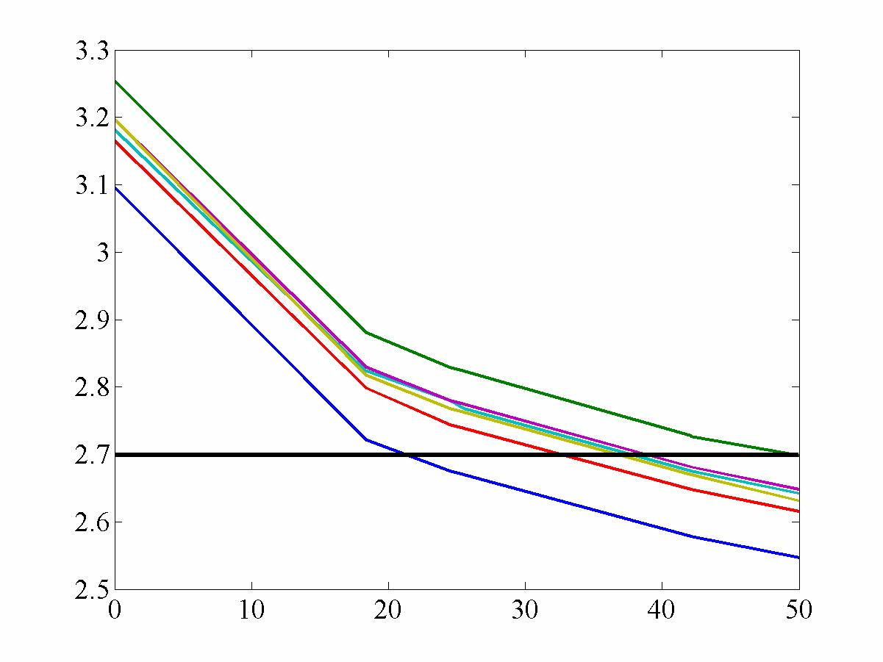
This application runs its communication functions constantly and transmits exclusively raw data measurements. Since communication functions are known to contribute more to energy consumption than any other operations, this test represents roughly the minimum possible battery lifetime that is reasonable.
Figure 1: Battery Voltage Decline in the Surge Network
Hours
Volts

We left the network running and measured the voltage levels over the course of several days. Figure 1 shows that each of the six experimental motes fell below the recommended operating level of 2.7 V within 50 hours of the time they were turned on. Below this level, the nodes showed erratic behavior, and the average time until complete node failure was only 110.5 hrs, or 4.6 days. We kept these results in mind when evaluating the capabilities of our final deployed sensor network.

Existing Technologies

Wireless sensor networks currently exist in many technologies with applications ranging from medical and structural to agricultural and environmental. Code Blue and Wisden, described below, are two projects that take advantage of the adaptable and on-demand tracking and monitoring functionalities of sensor networks. Because of the nature of these usages, batteries on sensors may be easily replaced and as such, energy consumption is not necessarily a major concern. Our design is constrained by battery lifetime and as such treats the problem of energy consumption more carefully. Additionally, the algorithms that we have considered may ultimately prove useful to these projects.

Code Blue: Wireless Sensor Networks for Medical Care

This is a project from Harvard University in collaboration with the Boston Medical Center. The goal is to extend wireless sensor networks to a range of medical applications including patient monitoring, emergency care and disaster response. In most of these scenarios, each patient would be fitted with a sensor mote that could monitor vital signs. In big hospitals or in nursing homes, a way to track vital signs to monitor patient health across the board efficiently is certainly helpful. During emergency calls, EMTs could attach sensors to patients, and any change in vital signs would be transmitted to the EMT’s PDA. Relevant information could also be communicated to the hospital more efficiently, enabling them to be better prepared for the patient’s arrival [5].

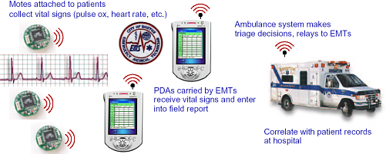

Figure 2: Example use of CodeBlue for emergency response (PDA displays real-time vital signs of multiple patients.)

Wisden: Wireless sensor networks for structural health monitoring

This project from Embedded Networks Laboratories uses Wireless sensor networks to evaluate the soundness of building structures. Sensor motes (Crossbow Mica2/ Micaz) are placed in strategic locations through the structure that will acquire data (vibrations, accelerations, etc.) that can be used to determine its health. They are running their software on the TinyOS platform. They support up to 200Hz of 3-axis acceleration data in a multi-hop mesh network [6].

Project Description and Specifications

The purpose of this project was to design and deploy a functional sensor network in Duncan Hall. We attempted to distribute the network over as large an area as possible given the distance required for reliable communication. This network transmitted locally processed data measurements from various locations in the hallway to one sink node and computer to be analyzed. The results of these measurements were used to create a data map which displayed temperature and light readings to within the accuracy tolerances specified below.

Project Deliverables:

- A deployed sensor network measuring light and temperature
- An implementation of a mesh-networking infrastructure
- A data map program to display the readings from the measurement area
- Optional: A wavelet transform algorithm running on top of the network

Assumptions

- Network is operating under good environmental conditions with few or no obstacles – We assume that there will be minimal outside interference and no extreme variations from normal climate conditions. This assumption is valid because it is necessary to establish performance in a stable environment before considering harsher conditions.

- Each node will be deployed within radio range of at least one other node – This is valid because if a node falls outside this range, it would simply not be considered part of the active network. Thus, any such node would simply be a wasted resource in our design.

- The motes will not be disturbed once deployed – This assumption is valid because in a large network deployment, we may expect that very few of the nodes will be moved in a short period of time. It is necessary because our wavelet transform assumes knowing a fixed location for each node. We also assume no unexplained node failure.

Design Goals:

- Deploy a functional network of 15 Crossbow Micaz motes with temperature and light sensors in Duncan Hall.
- Spread the network over as wide an area as possible given that each node must be within at least 20 feet of its nearest neighbor.
- Receive consistent data reports from this network for a period of at least one week: Nodes will transmit data to the sink (transmission rate given as 250 kbps) every 30 seconds.
- Maintain battery lifetime of at least two weeks.
- Create a data map which displays the measurement information and updates every 5 minutes
- Obtain temperature readings accurate to within 5 degrees and light readings accurate to within 10% of the actual values.

Results:

For Project Deliverables:
- We deployed sensor network which measures light and temperature.
- We achieved multi-hop routing capabilities in a de-centralized network, thus implementing some aspects of a mesh networking structure. We did not, however, implement neighbor discovery or dynamic routing.
- We created graphs for each node to display the light and temperature measurements over time.
- We implemented a wavelet transform algorithm to run on top of the network, but it does not return correct values for every node.

For Design Goals:
- There are 20 sensor motes in the network, thus meeting our goal for minimum size
- The network’s sink node was placed in the DSP/ Networks Lab, and the network stretched as far as the main atrium (see diagram in the following section). The distance between motes varied, but was usually fairly close to the 20 feet that we estimated in our initial specifications.
- Our longest deployment of the network lasted 48 hours. A major factor which limited the duration of the test was the battery lifetime discussed below. Additionally, the specification for data transmission was changed from 30 seconds to 3 minutes. This change reflected the forced communication delays required for reliable communication (described in the following section) and the time allowed for the wavelet transform to complete.
- Our final battery tests showed that voltage levels hit the 2.7 mark in roughly 24 hours. The longest fully functional test of the network lasted for at least 48 hours. Therefore, it seems like our performance roughly matched that of our original tests with “Surge” during which the nodes lasted for 2-4 days. This falls short of our goal of 2 weeks. Improving the battery lifetime will be an important consideration for future teams.
- We created a data file which received new readings every 3 minutes. This file was subsequently used to create a MATLAB data object that we analyzed for both the overall data map and individual node performance.
- Our temperature readings are accurate to within 5 degrees. The readings fall between 74 and 76 degrees Fahrenheit in an indoor climate. These results also tell us that our standard of 5 degrees was probably too broad; further experiments could most likely show that these measurements are just as accurate, if not more so than any hand-held thermometer. Light readings are harder to evaluate numerically because the motes do not provide their units of measurement. However, the key result, which applies to both light and temperature, is that the readings were accurate enough that we could use the resulting graphs to clearly distinguish events like the sunrise and the air conditioner turning on. (See the Results section for more details.)

Description of Design

The description of the design is divided into three sections as follows:

Overview – This section displays the topology of our deployed network and discusses the general features of our main nesC application.

Building Blocks – This section describes the specific components that we used to construct our network. It discusses the capabilities and limitations of the hardware and software, as well as the basic networking ideas that we implemented.

Results – This section analyzes the light and temperature data that we obtained from the network, as well as the performance of the network. It discusses to what extent we met our goals and what could be improved on by future teams.

Overview

Our Layout:

Figure 3 below shows the locations of all of the sensor motes in our fully deployed network on the second floor of Duncan Hall. The numbers represent the node IDs of individual motes, and the blue lines show the communication routes that the motes used. Our data sink was connected to node 1.

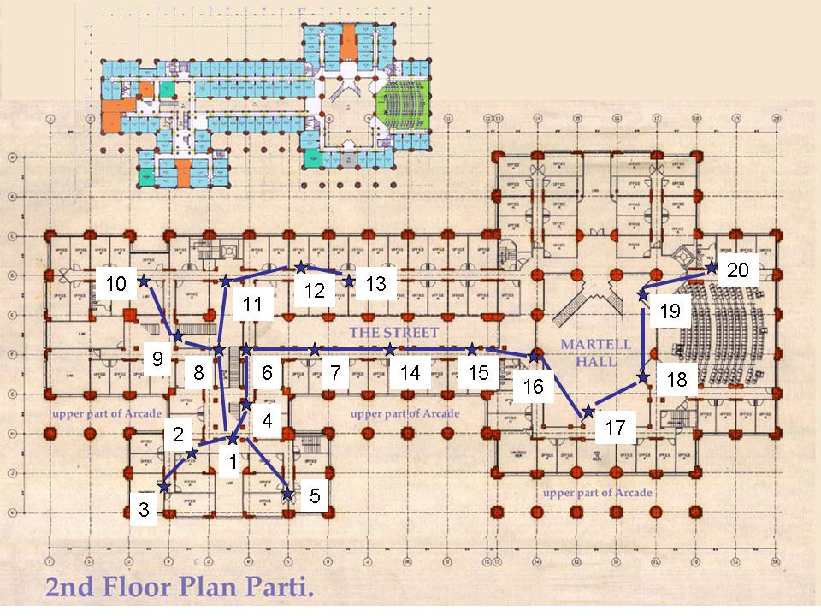
Figure 3: Map of the 2nd floor of Duncan Hall showing the location of all 20 motes and the motes they route to.

Basic Routing:

The main component of our design is a single nesC application, called “BasicRouting,” that we load onto each of the motes. The application follows the same basic structure that we defined last semester. Each of the sections (Input, Output, and Processing) is connected by an interface object (SensorOutput.nc) that passes along the relevant parameters. These parameters include source, next hop, and final destination fields for routing purposes, as well as an array of data that represents the measurements taken by the sensors.

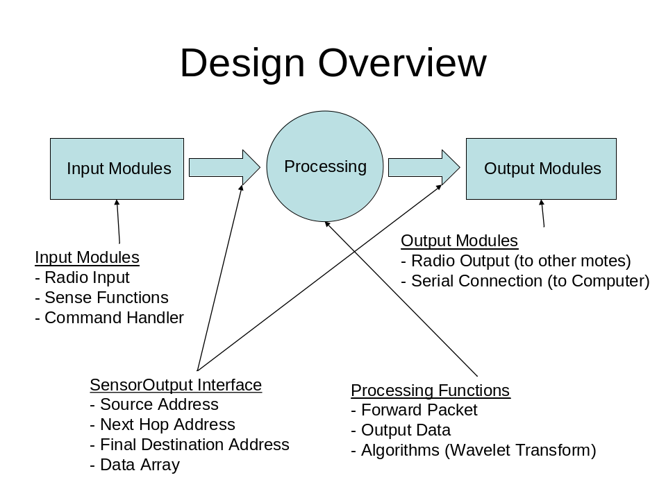

Figure 4: An overview of the system

The possible input sources for our application include radio inputs (signals from another mote), sensing functions (temperature and light measurements), and a command handler which responds to broadcast commands from the base station. This command handler uses the same hardware as the radio. The processing block covers any function that the node could perform between receiving an input and generating an output. This includes receiving a packet, deciding that its final destination is elsewhere, and choosing to forward it. The processing step could instead entail receiving a command to execute a wavelet transform and sending its coefficient to its neighbors. The possible output modules are basically limited to sending a packet over the radio or delivering a packet to the computer over the serial port. We also used the LED output, but only for debugging purposes.

Building Blocks

Sensor Measurements:

This project uses “Micaz” motes from Crossbow Technology [3]. These motes have an open dock that can be connected to a variety of components. One such component is the MTS 310 Sensor Board which has light, temperature, and acoustic sensors, among others. Upon connection, the data readings from the sensors will be available to the processor on the motes. There are nesC library files which can read data from the device drivers and pass it to the main function through various interfaces.

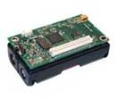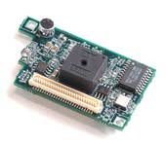

Figure 5: The MTS 310 Sensor Board (left) and Micaz Mote (right) from Crossbow Technologies.

NesC Programming:

The nesC programming language consists of linking modules, configurations, and interfaces to build programs. A configuration is the main file for a program that links the input and output modules to any sub-modules that it may contain. A module is a basic program unit (represented by ovals in Figure 6) that defines all relevant functions. An interface (represented by the arrows with words) is the link between modules. For example, in the diagram, the BasicRouting module connects to the SensorToRfm module via the SensorOutput interface.

A command is a function in which the caller asks the callee to do something. An event is a function in which the caller waits for a signal from the callee and then does something itself. The interfaces in black involve one module calling a command in the module to which the arrow is pointing. The interfaces in red involve one module waiting for a signal from the module from which the arrow originated. For example, the SensorToRfm module uses the SendMsg interface to call the “send” command in the Comm module. In the RfmToSensor module on the other hand, the “receive” event is signaled by the Comm module via the ReceiveMsg interface.

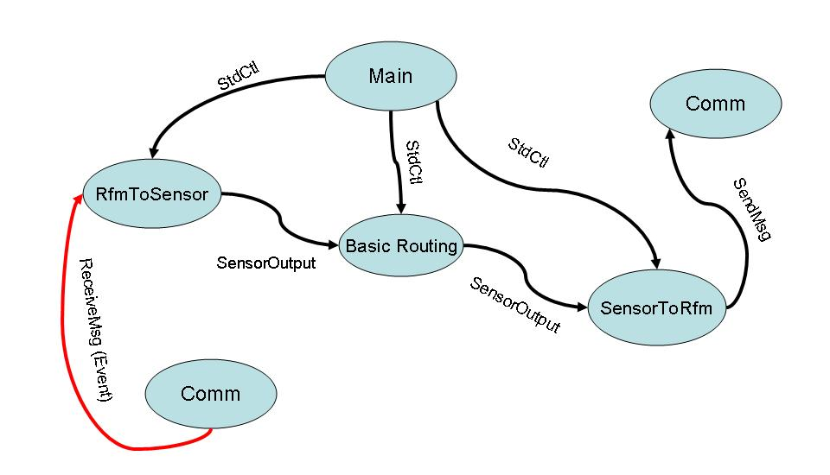

Figure 6: The NesC modules and interfaces that make up the BasicRouting program

In addition to being a good example of basic nesC programming, Figure 6 depicts the basic outline of our system at a more detailed level than the overview. The Comm and RfmToSensor modules help each node receive data from the radio and send it to the main processing module which is called Basic Routing in this diagram. This module may do something as simple as forwarding the packet to another node, or as complicated as calculating and sending wavelet coefficients based on the data. The SensorToRfm and Comm modules allow the processing module to send its data out over the radio.

The final important component of the nesC language is the packet structure for radio transmission. The message structure may be defined as a struct object in a header file. For our design, this will include next address and final address parameters for multi-hopping, as well as an array of sensor measurements. The transmission command takes this message object and a destination address as parameters. If the destination address is a single node, then only this node will attempt to receive the message data. The address may also be “broadcast” which would send to all nodes or “UART” which would send data to the computer over the serial port. Our design distinguishes “commands” from “data packets,” but a command is simply a packet that uses the “broadcast” address, originates from the sink node, and conforms to a slightly different message structure.

See the appendix on page 24 for the complete nesC code used in our program.

Routing Decisions:

Wireless networks are decentralized structures that involve each node connecting to at least one other node that is within one radio hop. As a result, each node can access a route to any other

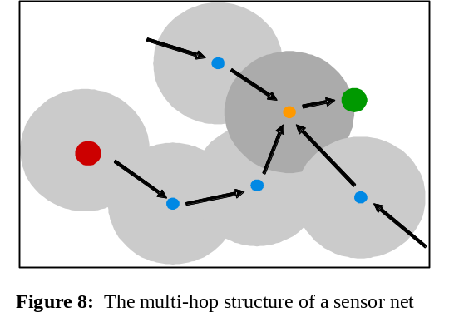
node in the network through its nearest neighbors. This means that each node must function as a repeater to pass on data from one node to another. We can thus spread out communication over a large network with little additional infrastructure.

For our purposes, multi-hop routing is important since we spread the network out to cover a large area.

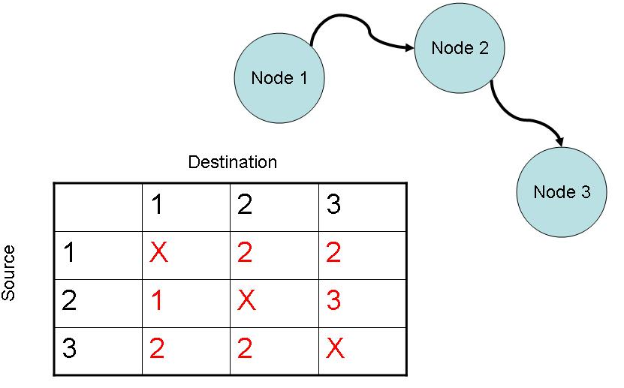
Each node contains in memory a pre-determined routing table to facilitate the multi-hop routing. The table is a 2D array that shows which node this node must transmit to in order to ultimately reach its destination node. A node does not need to know the structure of the entire network, only the nodes that it sends to next. When a node receives a packet, it can simply access the packet’s final destination parameter and then look up in its routing table to determine which node it will forward this packet to in order to reach this

destination.

Figure 7: A routing table for a basic network

We chose this model because it supports multi-hop communications and it is decentralized. It is also well-suited for supporting the wavelet transform and other extension algorithms. We had to test the network several times to determine that our table was valid. We first mapped out the locations of all of the motes we would deploy. Then we created a routing table that we thought would work for this layout. Deploying the motes to their proposed locations, we could tell empirically which ones were establishing communication with their neighbors and which were not. We then repositioned the ones that were not and updated our map.

Distributed Wavelet Transform:

Current research in sensor networks has concluded that, whenever possible, the transmission of information in the sensor network should take the form of summarized results and conclusions rather than raw data. Thus, the individual sensor motes perform processing on their raw measurements and send back only the key information to the data sink. The processing should be “distributed,” meaning that it does not require all of the data to be in a central location. It should also be “localized,” meaning that it only requires that data from that sensor mote and those in its immediate vicinity [7]. The wavelet transform is one type of this distributed and localized processing.

Wavelets are a way of representing a signal based on an average value and a set of differences from that average. Wavelets essentially “decorrelate” a signal by making the important information cluster in a few points; for example, a program could encode the two largest values and set all of the smaller coefficients to zero. In this way, a signal of large values can be represented in not too many bytes. This data compression would reduce the amount of information that the motes will need to transmit and could therefore eventually help in reducing power consumption.

Sensor networks usually consist of an unstructured grid, since the nodes are often deployed opportunistically. Fourier Transforms don’t apply here, but the process of “lifting” can be employed. Lifting is a method of filtering, except it is used in the time/spatial domain. It involves using a rule to split the network into even and odd parts and then performing predict and update operations. Lifting is an iterative process where the scaling coefficients (S_{j}) that are calculated in one round are the inputs to the next round. W_{j} are the wavelet coefficients [8].

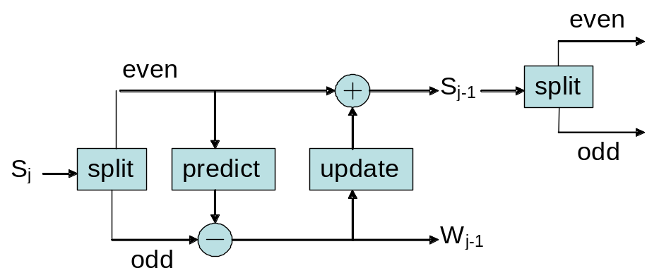

Figure 9: The basic algorithm for a distributed wavelet transform: calculating the Wavelet
coefficients (W_{j-1}) and the scaling coefficients (S_{j})

In our sensor network, the initial parameters needed to perform the lifting for the wavelet transform are be given: the even/odd split, the neighborhood, and what set of values to scale the measurements by. Our program uses the measured light and temperature values as the initial scaling coefficients and then calculates the new scaling values, as well as the wavelet coefficients, for each step in the transform. For each level, certain nodes are designated as “predict” nodes, and others are dedicated as “update” nodes. The update nodes send their scaling values to their neighbors who are being predicted. Each predict node then multiplies the received scaling values by coefficients and subtracts them from its current value. The result is a new wavelet coefficient for this level, which the predicted node sends to all of its neighbors, which are update nodes. Each update node multiplies all of the received wavelet values by coefficients and adds them to its current value. The result is a scaling coefficient for this level, which is used in the next level of the transform. After a node has been predicted, it retains its final wavelet coefficient and doesn’t participate in subsequent levels of the transform. Figure 17 in the appendix shows the predict and update nodes for different levels of the wavelet transform for our particular network.

Experiment Results

Light and Temperature Data Collection:

We deployed our network of 20 motes in Duncan Hall for a period of 48 hours. These nodes reported back values for light and temperature every three minutes. Figures 10 and 11 below show graphs of selected nodes for light and temperature over this period. Despite some points of data corruption, these graphs are generally accurate enough to detect trends in the environment such as light intensity increasing during the day or temperature decreasing when the air conditioner turns on.

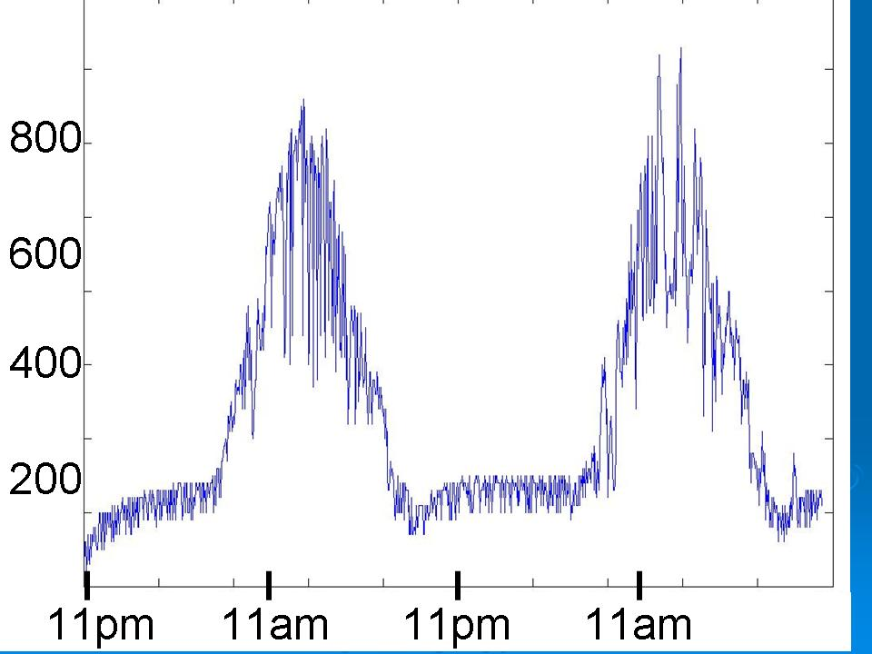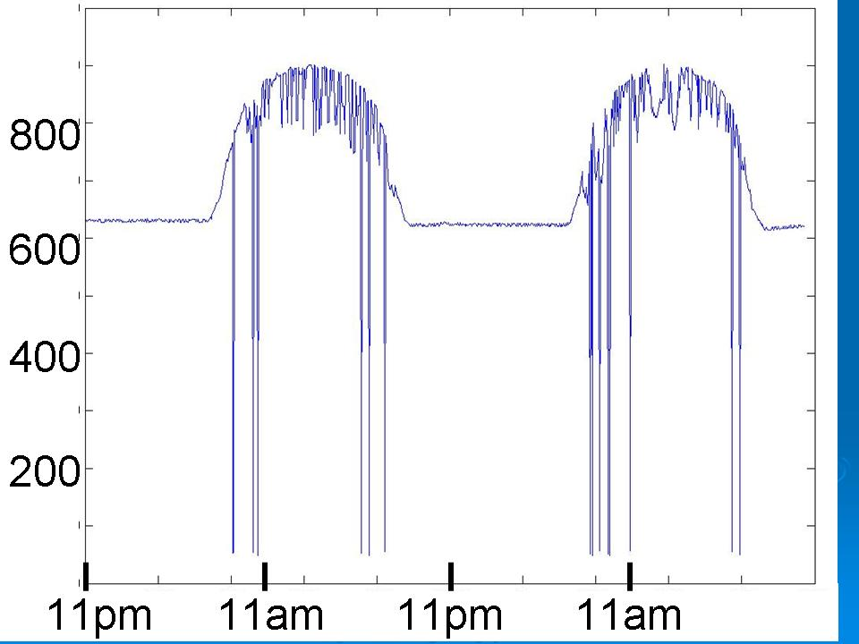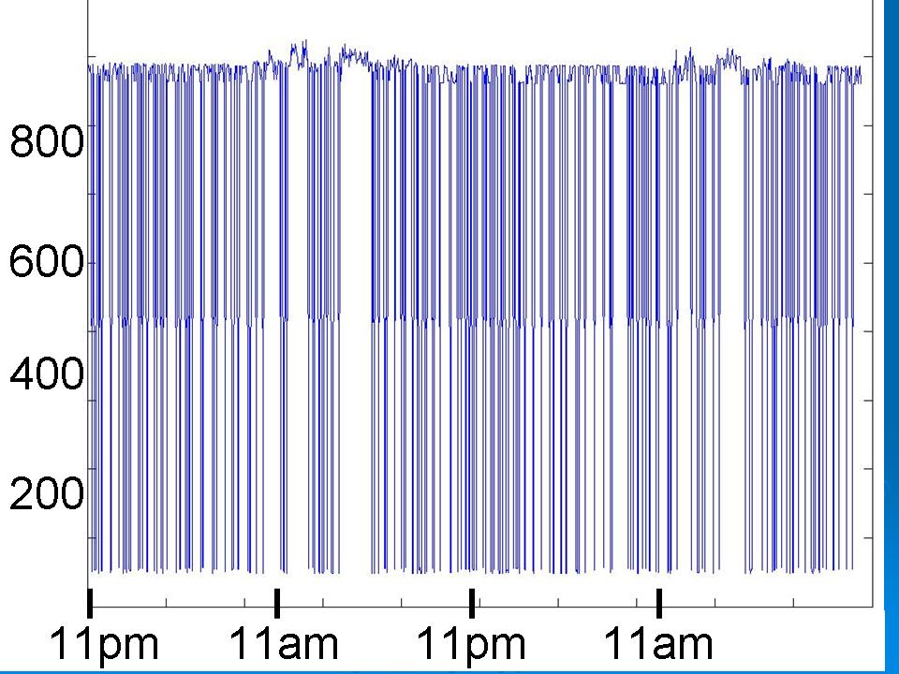

Figure 10: Light readings over a 48-hour period for motes #1, 14, and 3 (from left to right)

The first graph depicts the light data sent back from node 1. This graph is intuitive since there is a clear trend of light values going up during the day and down at night. The second graph shows the data for node 14, which follows a similar trend. This makes sense since nodes 1 and 14 were placed in areas that had different light levels depending on what time it was. For example, node 14 was in the hallway and in the path of sunlight through windows and additional indoor lighting that is normally dimmed at night. The third graph shows the data from node 3, which is quite interesting. Node 3 was placed outside an office, and the lighting in its surrounding environment was pretty uniform. One of the reasons the data seems to oscillate so much could be people walking in and out of the area and frequently interrupting the light from getting to the mote. Another explanation for this variation could be the flicker of the fluorescent light that it was beneath. Finally, the sensor board itself may be at fault. The lowest values reported are way off any feasible light readings; thus, hardware failure is a possibility. Overall jaggedness and spikes in the graphs, as we also see in the first two graphs, could be accounted for by milder variations of any of the issues mentioned above. Additionally, we face the problem of dropped or corrupted packets during transmission, which would also cause corruption in the results.

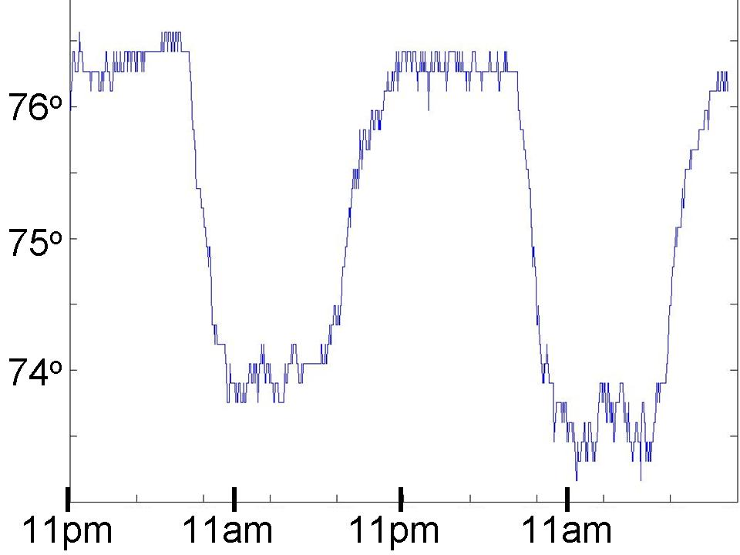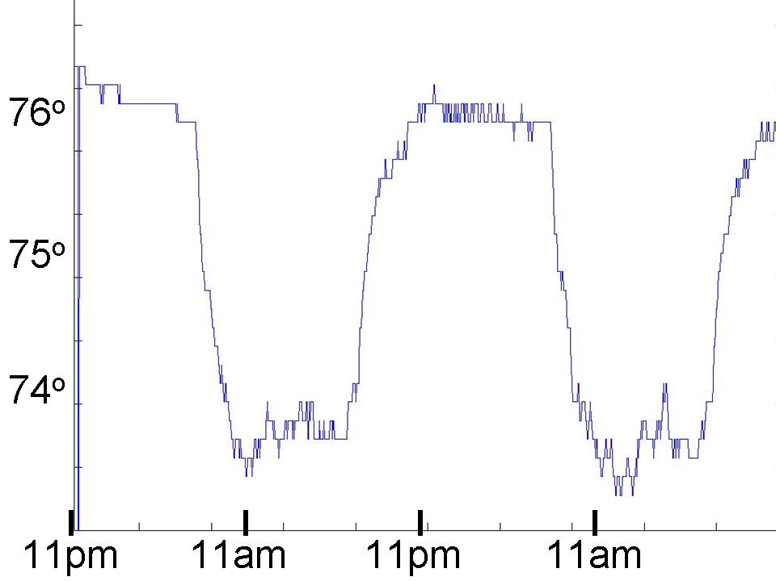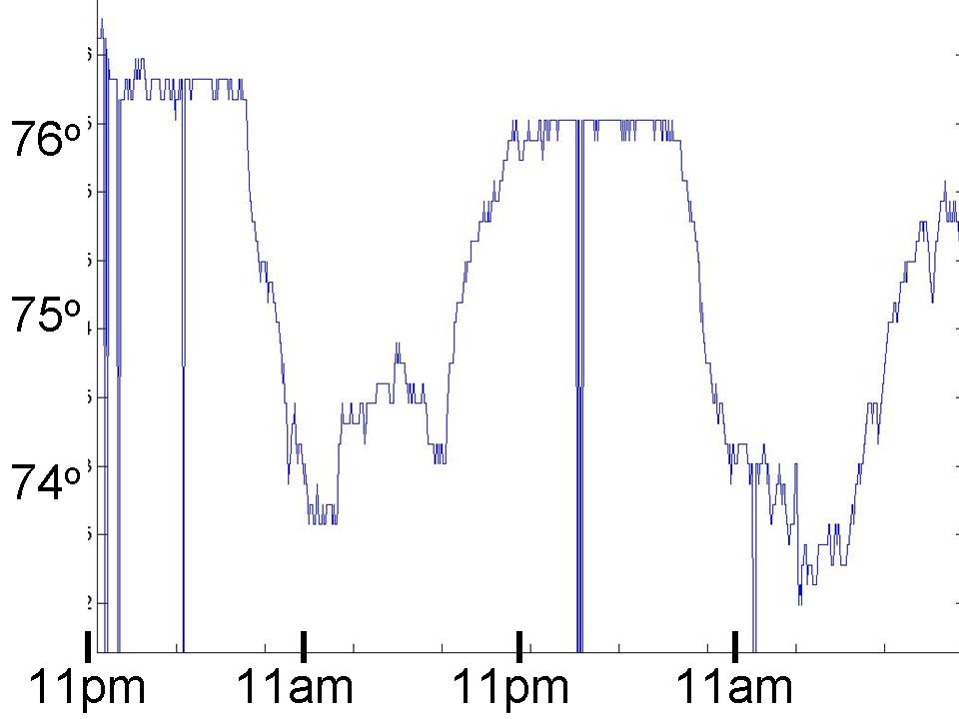

Figure 11: Temperature readings over a 48-hour period for motes #7, 14, and 15 (from left to right)

The left-most graph in figure 11 depicts the temperature data sent back from node 7. The increase of temperature by a few degrees during the night hours can be easily explained by the fact that the air conditioning is turned off during this time. The second and third graphs show data from nodes 14 and 15 that generally agree with this trend. However, they have some spikes downward that could be explained by the reasons outlined for inconsistencies in the light data: People (or warm bodies) entering the environment, possible hardware failures and dropped/corrupted packets.

Battery Lifetime:

In addition to the light and temperature data collection, we ran a separate experiment to test the battery voltage over time. We deployed a network of eight nodes and had them report back their voltage every five minutes for a 24-hour period. Figure 12 shows the initial and final battery voltage for each of these motes, which were mostly between 2.9 and 3.0 volts and 2.6 and 2.7 volts, respectively.

Node ID | Initial Battery Voltage  (in volts) | Battery Voltage  After 24 hours  (in volts)
1 | 3.047 | 2.659
2 | 2.947 | 2.676
3 | 2.933 | 2.631
4 | 2.947 | 2.670
5 | 2.879 | 2.609
8 | 2.947 | 2.682
9 | 2.961 | 2.642
10 | 2.933 | 2.648

Figure 12: The initial and final battery voltage for 8 motes in our network after a deployment of 24 hours

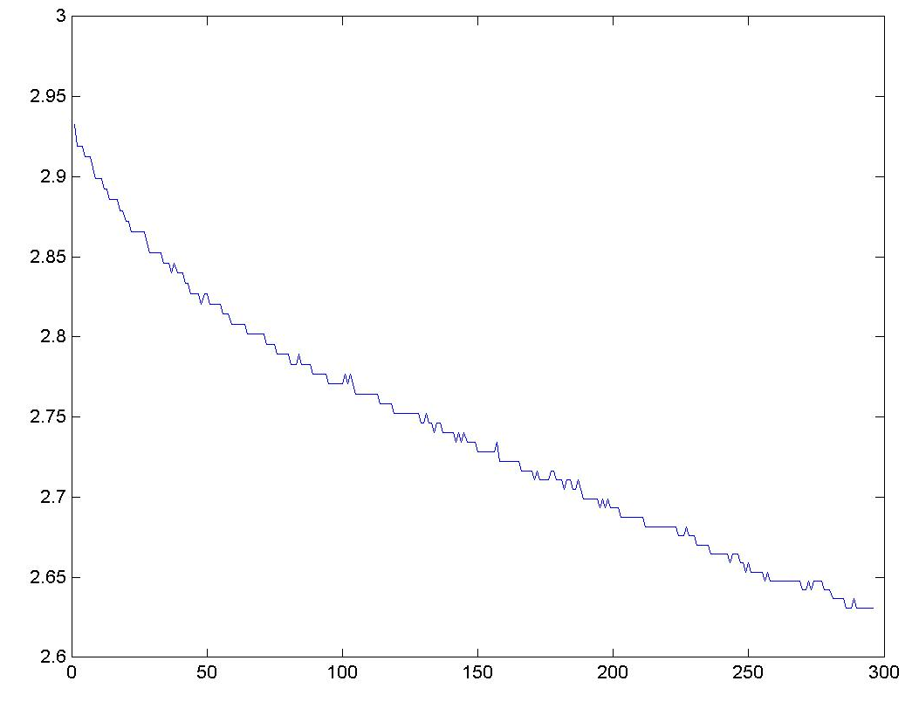
This graph shows the battery voltage over time for node 3, and is representative of the behavior of the different motes in our deployment. We can see that the voltage decays exponentially over a 24-hour period. The average lifetime of a node turned out to be in the region of 48 hours, so there is obviously room for improvement. A sleeping algorithm, for example, could be implemented to effectively “turn off” nodes in the network during periods of inactivity.

Figure 13: Battery voltage (in Volts) for mote #3 over a 24-hour
period (voltage measured every 5 minutes; 300 total measurements)
Node Transmission Success:

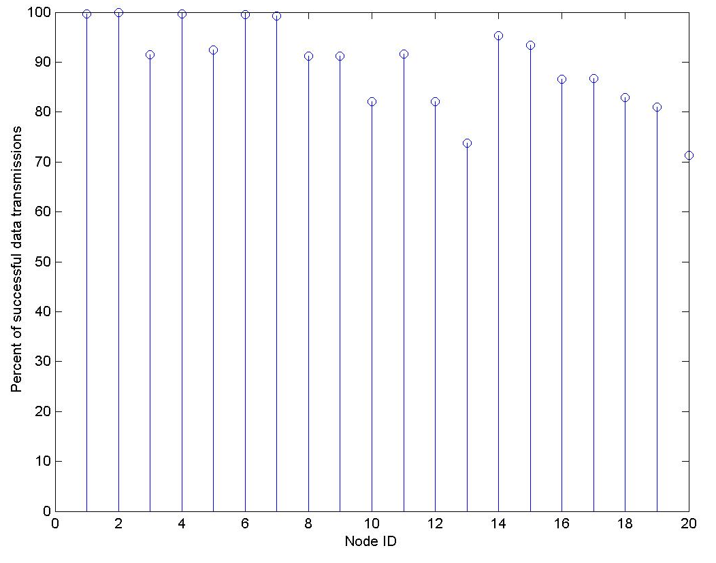
Figure 14 show the percentage of times that a given node’s data was successfully received by the base node. We can see that nodes more hops away from the data sink had a lower success percentage than those closer to the base. This is especially true for nodes 15-20 which are in a long chain (see our mote layout in figure 3); the percentage of packets received by the base decreases the further down in the chain the node is. There are also some nodes that are just worse than others, such as nodes 3, 5 and 10, for other reasons: these nodes are probably connected to other nodes through weak links due to distance, obstacles, or Figure 14: Percentage of successful data transmissions per node
other environmental conditions.

Wavelet Transform:

The results of our wavelet analysis were largely unsuccessful, but nonetheless instructive. Taking the inverse wavelet transform on the wavelet values returned by the network should give the same initial light and temperature readings that the motes took; however, the most accurate wavelet transform frames that we could find still had noticeable error. We observe that the most significant errors tended to be in nodes like 7 and 14 which were at the very end of the sequence in the transform (see figure 17 in the appendix for the participation of different nodes in different levels of the transform), and in nodes like 12 and 13 which were notoriously unreliable communication hops in general, as figure 14 shows. These latter nodes had great error because they often dropped their own packets and the former nodes had great error because they could not complete the transform if any node before them in the sequence failed to complete.

The first set of data comes from a frame that had relatively low error. The graph on the left shows the reported wavelet values of the light readings for this frame (shown with ‘O’s) and the expected wavelet values (shown with ‘X’s) obtained by running the raw values through the wavelet transform in MATLAB. The graph on the right shows a similar analysis of the light readings themselves. The ‘X’s represent expected values computed by running an inverse transform on the reported wavelet values and the ‘O’s represent the reported light measurements.
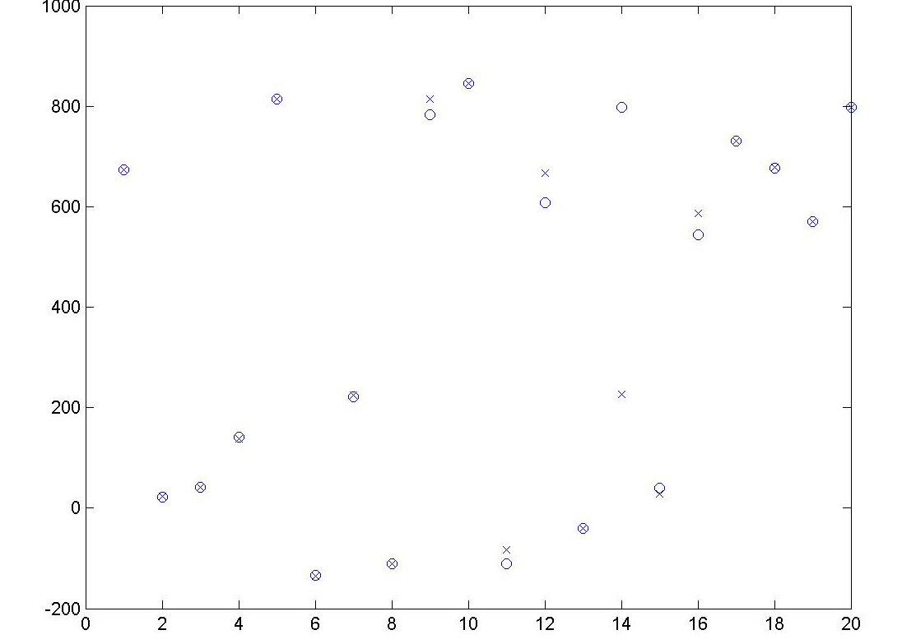
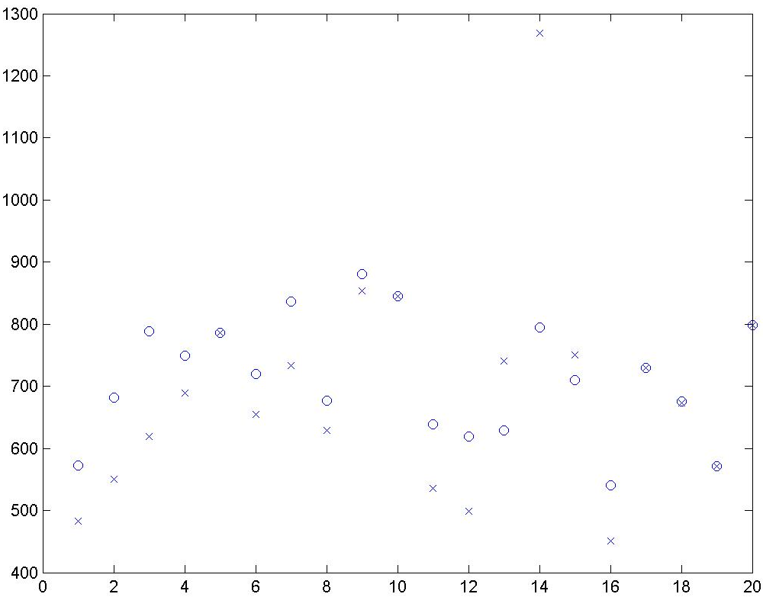

Figure 15: The expected (‘X’) and the actual (‘O’) wavelet light results for each node in the network after one wavelet transform operation

The first point to note from these graphs is that small error in the wavelet transform becomes much larger after it is decompressed. The second point is that errors are indeed more likely to appear at nodes which predict themselves later in the transform. Our analysis of many frames suggests that nodes 7 and 14 (the last two to predict) are very often in great error. The following graphs show the same data but for temperature and for a different frame. The error seen here is much more typical of the error seen in the average frame.
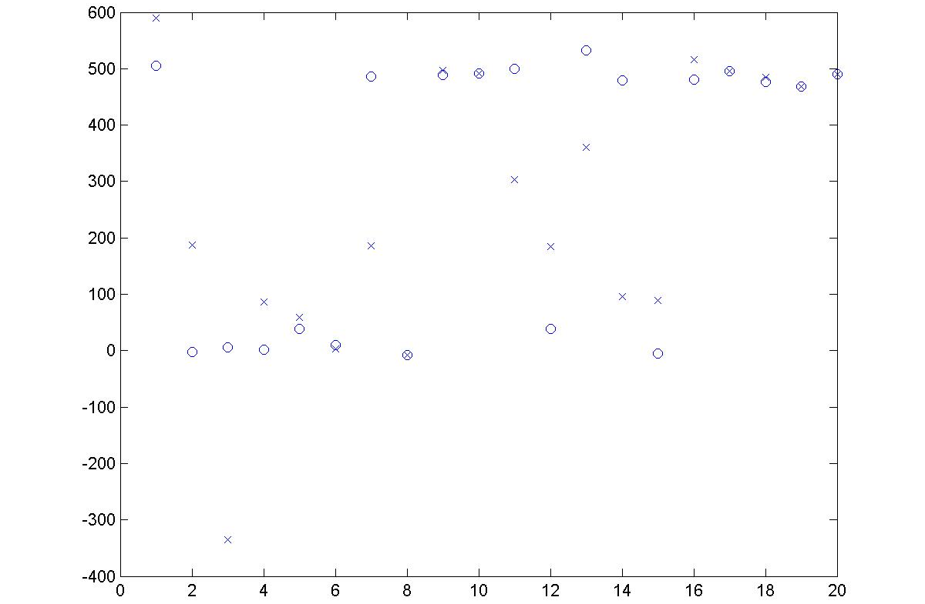
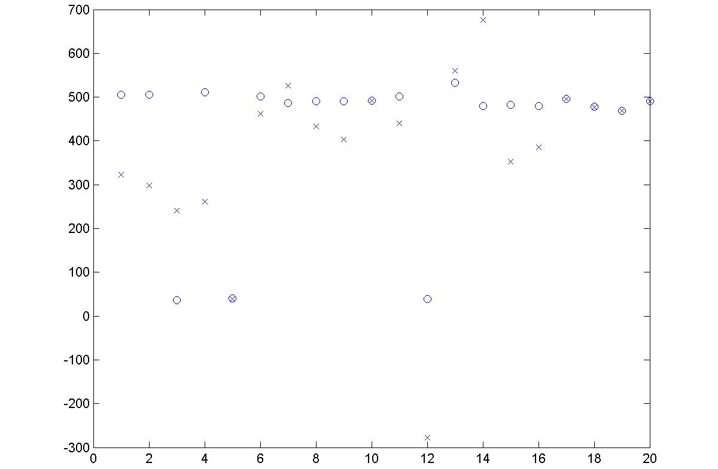

Figure 16: The expected (‘X’) and the actual (‘O’) wavelet temperature results for each node in the network after one wavelet transform operation
The conclusion from these results is that the wavelet transform suffers immensely when any packet is dropped. Thus, in order to make this technique viable, we would need to reduce the number of dropped packets and change the way the system responds to dropped packets. The first issue, reliability, could be addressed by adding acknowledgements and forced retransmission calls to the communication system. The second issue, response to dropped packets, could be addressed by changing the way the transform runs. A new approach would call for the transform to make an educated guess of a missing value and continue, rather than make the entire transform halt.

Extensions

In light of these results, there are several possible extensions to our project that could improve performance, especially in the areas of battery lifetime and wavelet accuracy.

- MAC Layer - Implement a MAC (“Medium Access Control”) layer protocol. In other words, develop a system of acknowledgements at the MAC level to make communication more reliable. As it stands now, nodes do not send back any acknowledgements if they receive data making it very difficult to work around dropped packets.

- Ensure wavelet transform completion - Modify the wavelet execution to determine whether or not a node has received all of the values it should in order to correctly predict or update itself in a given level of the wavelet transform. If, after a designated period of time, it has not received all of the values it should, it refers to the value that it last received from the missing node. This will allow the wavelet transform to complete more reliably, even in the case of unreliable communication.

- Sleeping Protocol - One straightforward approach to the energy problem is to discontinue all but essential radio activity by putting the nodes on a sleeping schedule. This means that they “go to sleep,” or switch to a low power mode, when they do not need to communicate or acquire data. The effectiveness of this technique depends on the duration of the sleeping time and the overall sleep schedule/algorithm [9].

- Mesh Networking – Another extension to this project is to implement certain features from mesh networking such as neighbor discovery and dynamic routing capabilities. This would enable us to add and subtract nodes from the network without loss of functionality.

Summary and Conclusions

The primary concern of our design was to deploy a network that measures light and temperature and is able to consistently transmit these readings to the data sink. We achieved this with a single program that runs on all of the motes in our network. This program could additionally be rewritten to perform distributed signal processing techniques on the data. We implemented an in-network wavelet transform, and future groups will be able to explore different algorithms.

Our design meets our objectives for the most part: we deployed a network of 20 motes for 48 hours which took light and temperature readings and analyzed the results. Graphs from individual nodes are accurate enough to detect trends in the environment such as light intensity increasing during the day or temperature decreasing when the air conditioner turns on. However, energy consumption is still a problem; we have not met our original goal, and this is an area that needs improvement.

The basic program that we have provided produces good results most of the time. The wavelet transform, however, still needs further work to be accurate. Communication is still not completely reliable and thus a system of acknowledgments is needed to ensure transmission success. Also, we need to further investigate why certain nodes return unrealistic values some of the time. Overall, our project represents a significant first step to creating a sensor network with many possible areas for future work.

Appendices

Team Roster

Project Members:
- Aditya Nag (anag@)
- Ben Weidman (bweidman@)
- Gina Upperman (upperman@)

Responsibilities shared by all members:
- Master basic skills related to NesC and TinyOS environments
- Deploy full network to provide adequate test of sensing capabilities
- Create program in nesC which performs wavelet transform

Aditya’s Responsibilities:
- Research basic networking principles and determine how they apply to our system
- Create a program in nesC which configures motes to return data measurements
- Create data map and individual node graphs from results of this experiment

Ben’s Responsibilities:
- Perform tests with existing software to determine reliable communication distance
- Develop basic structure of the program that other features can connect to
- Configure pre-existing sensor modules to interface with this program

Gina’s Responsibilities:
- Research wavelet transform and lifting algorithms to compress the data; understand MATLAB programs which perform wavelet analysis
- Deploy motes in small groups to determine reliable communication routes
- Perform tests with existing software to determine reasonable battery lifetime

Engineering Drawings

Figure 17: This table shows the behavior of each of the 20 nodes in our network during the wavelet transform. For our given layout, there are three levels of the transform. Nodes with a ‘P’ are being predicted in this level. Once a node is predicted it doesn’t participate in any subsequent levels of the transform (‘X’). Nodes with a ‘U’ are being updated in this level. Nodes with a blank space also do not participate in a particular level of the transform.

 | Level
Node | 1 | 2 | 3
1 | U | U | U
2 | P | X | X
3 | U | P | X
4 | P | X | X
5 | U | U
6 | U | P | X
7 |  | U | P
8 | P | X | X
9 | U | U
10
11 | U | P | X
12 |  | U | U
13 |  | P | X
14 |  | U | P
15 |  | P | X
16 |  | U
17
18 |  | U
19
20

Program Listing

Code Index

- BasicRouting.nc - The main configuration for our sensor network. It can take input data from a variety of sources (Rfm, Sense, Cnt, etc), process that data using COMPASS algorithms, and send it out to several other sources (Rfm, Leds, UART, etc).

- BasicRoutingM.nc – The implementation of BasicRouting.nc.

- CPUMsg - Stores information about the message that will be sent across the UART to the PC.

- MsgSndRcv.nc - Sends data from the SensorMsg type to the Rfm Output Stack or the UART port, using the Transceiver code. It also receives messages from the Rfm Input Stack. It may be used for single or mulit-hop communications.

- ProcessCmd.nc – An interface for processing command inputs.

- SensorMsg.nc – Reads a message (SensorMsg) from the Rfm stack and sends it to the main part of the program using the SensorOutput Interface.

- RfmToSensor.nc - Reads a message (SensorMsg) from the Rfm stack and sends it to the main part of the program using the SensorOutput Interface

- RfmToSensorM.nc – The implementation of RfmToSensor.nc.

- SenseToSensor.nc – Takes data readings from the sensor (light and temperature) to store on a mote.

- SensorMsg.h – The message type for SensorToRfm/RfmToSensor.

- SensorToRfm.nc – Sends data from the SensorMsg type to the Rfm Stack. It may be used for single or multi-hop communications.

- SensorToRfmM.nc – The implementation of SensorToRfm.nc.

- SensorToUart.nc - Sends data from the SensorMsg type to the Rfm Stack. It may be used for single or multi-hop communications.

- SensorToUARTM.nc – The implementation of SensorToUart.nc

- SensorToLeds.nc – Sends data from the SensorMsg type to the Leds. We use this for debugging and demos.

- SensorToLedsM.nc – The implementation of SensorToLeds.nc.

- SimpleCmd.h - This header file defines the AM_SIMPLECMDMSG and AM_LOGMSG message types for the SimpleCmd and SenseLightToLog applications.

Disclaimer from TinyOS (based on an open source code framework)

/* "Copyright (c) 2000-2003 The Regents of the University of California.
* All rights reserved.
*
* Permission to use, copy, modify, and distribute this software and its
* documentation for any purpose, without fee, and without written agreement is
* hereby granted, provided that the above copyright notice, the following
* two paragraphs and the author appear in all copies of this software.
*
* IN NO EVENT SHALL THE UNIVERSITY OF CALIFORNIA BE LIABLE TO ANY
* PARTY FOR DIRECT, INDIRECT, SPECIAL, INCIDENTAL, OR CONSEQUENTIAL
* DAMAGES ARISING OUT OF THE USE OF THIS SOFTWARE AND ITS
* DOCUMENTATION, EVEN IF THE UNIVERSITY OF CALIFORNIA HAS BEEN
* ADVISED OF THE POSSIBILITY OF SUCH DAMAGE.
*
* THE UNIVERSITY OF CALIFORNIA SPECIFICALLY DISCLAIMS ANY
* WARRANTIES, INCLUDING, BUT NOT LIMITED TO, THE IMPLIED WARRANTIES
* OF MERCHANTABILITY AND FITNESS FOR A PARTICULAR PURPOSE. THE
* SOFTWARE PROVIDED HEREUNDER IS ON AN "AS IS" BASIS, AND THE
* UNIVERSITY OF CALIFORNIA HAS NO OBLIGATION TO PROVIDE MAINTENANCE,
* SUPPORT, UPDATES, ENHANCEMENTS, OR MODIFICATIONS."
*
* Copyright (c) 2002-2003 Intel Corporation
* All rights reserved.
*
* This file is distributed under the terms in the attached INTEL-LICENSE
* file. If you do not find these files, copies can be found by writing to
* Intel Research Berkeley, 2150 Shattuck Avenue, Suite 1300, Berkeley, CA,
* 94704. Attention: Intel License Inquiry.
*/
/*
* Authors: Jason Hill, David Gay, Philip Levis
* Date last modified: 6/25/02
*
*/

BasicRouting.nc

/**
* This application is the main configuration for our sensor network. It can take input data from a
* variety of sources (Rfm, Sense, Cnt, etc), process that data using COMPASS algorithms, and send it out to
* several other sources (Rfm, Leds, UART, etc)
**/

includes SensorMsg;
includes SimpleCmdMsg;

configuration BasicRouting {
}

implementation {
components Main, BasicRoutingM, SensorToLeds, SenseToSensor,
TimerC, PhotoTemp, UARTComm as Comm, TransceiverC, MsgSndRcv, Voltage;

Main.StdControl -> BasicRoutingM.StdControl;
Main.StdControl -> SensorToLeds.StdControl;
Main.StdControl -> MsgSndRcv.StdControl;
Main.StdControl -> SenseToSensor.StdControl;
Main.StdControl -> TransceiverC;
Main.StdControl -> TimerC;

/* For use with the light and temperature sensors */
SenseToSensor.Timer -> TimerC.Timer[unique("Timer")];
SenseToSensor.LightOutput -> BasicRoutingM.LightIn;
SenseToSensor.TempOutput -> BasicRoutingM.TempIn;
SenseToSensor.LightADC-> PhotoTemp.ExternalPhotoADC;
SenseToSensor.TempADC-> PhotoTemp.ExternalTempADC;
SenseToSensor.LightControl -> PhotoTemp.PhotoStdControl;
SenseToSensor.TempControl -> PhotoTemp.TempStdControl;

MsgSndRcv.SensorOut -> BasicRoutingM.RadioIn;

BasicRoutingM.SensorTimer -> SenseToSensor.SensorTimer;
BasicRoutingM.RadioOut -> MsgSndRcv.SensorIn;
BasicRoutingM.LedOut -> SensorToLeds.SensorOutput;
BasicRoutingM.UARTOut -> MsgSndRcv.UARTIn;
BasicRoutingM.Transceiver -> TransceiverC.Transceiver[AM_SIMPLECMDMSG];

/* For use with the battery measurement */
BasicRoutingM.VoltageControl->Voltage.StdControl;
BasicRoutingM.VoltageADC->Voltage.ADC;
}

BasicRoutingM.nc

/**
* This application is the main module for our sensor network. It will implement the features
* that the configuration should perform. It will be able to take input data from a variety of
* sources (Rfm, Sense, Cnt, etc), process that data using COMPASS algorithms, and send it out to
* several other sources (Rfm, Leds, UART, etc)
**/

includes SensorMsg;

module BasicRoutingM
{
uses {
interface SensorOutput as RadioOut;
interface SensorOutput as LedOut;
interface SensorOutput as UARTOut;
interface Transceiver;
interface Timer as SensorTimer;

interface StdControl as VoltageControl;
interface ADC as VoltageADC;
}

provides {
interface SensorOutput as RadioIn;
interface SensorOutput as TempIn;
interface SensorOutput as LightIn;
interface ProcessCmd;
interface StdControl;
}
}

implementation
{
/* The routing table for our 20-node network (21 nodes including the base node #0). There is one row in the table * for each node in the network, and the columns give the node ID of the node that this row's node will need to route * through in order to get to this column's node (gives us next_addr).
*/

uint16_t routing_table[21][21] = {{-1,1,1,1,1,1,1,1,1,1,1,1,1,1,1,1,1,1,1,1,1},
{0,-1,2,3,4,4,4,4,8,8,8,8,8,8,4,4,4,4,4,4,4},
{1,1,-1,3,1,1,1,1,1,1,1,1,1,1,1,1,1,1,1,1,1},
{2,2,2,-1,2,2,2,2,2,2,2,2,2,2,2,2,2,2,2,2,2},
{1,1,1,1,-1,5,6,6,1,1,1,1,1,1,6,6,6,6,6,6,6},
{1,1,1,1,1,-1,1,1,1,1,1,1,1,1,1,1,1,1,1,1,1},
{4,4,4,4,4,4,-1,7,4,4,4,4,4,4,7,7,7,7,7,7,7},
{6,6,6,6,6,6,6,-1,6,6,6,6,6,6,14,14,14,14,14,14,14},
{1,1,1,1,1,1,1,1,-1,9,9,9,9,9,1,1,1,1,1,1,1},
{8,8,8,8,8,8,8,8,8,-1,10,11,11,11,8,8,8,8,8,8,8},
{9,9,9,9,9,9,9,9,9,9,-1,9,9,9,9,9,9,9,9,9,9},
{8,8,8,8,8,8,8,8,8,8,8,-1,12,12,8,8,8,8,8,8,8},
{11,11,11,11,11,11,11,11,11,11,11,11,-1,13,11,11,11,11,11,11,11},
{12,12,12,12,12,12,12,12,12,12,12,12,12,-1,12,12,12,12,12,12,12},

{7,7,7,7,7,7,7,7,7,7,7,7,7,7,-1,15,15,15,15,15,15},
{14,14,14,14,14,14,14,14,14,14,14,14,14,14,14,-1,16,16,16,16,16}, {15,15,15,15,15,15,15,15,15,15,15,15,15,15,15,15,-1,17,17,17,17},
{16,16,16,16,16,16,16,16,16,16,16,16,16,16,16,16,16,-1,18,18,18}, {17,17,17,17,17,17,17,17,17,17,17,17,17,17,17,17,17,17,-1,19,19},
{18,18,18,18,18,18,18,18,18,18,18,18,18,18,18,18,18,18,18,-1,20}, {19,19,19,19,19,19,19,19,19,19,19,19,19,19,19,19,19,19,19,19,-1}};

// The routing table for our 13-node network
// uint16_t routing_table[14][14] = {{-1,1,1,1,1,1,1,1,1,1,1,1,1,1},{0,-1,2,3,4,4,4,4,8,8,8,8,8,8},
// {1,1,-1,3,1,1,1,1,1,1,1,1,1,1},{2,2,2,-1,2,2,2,2,2,2,2,2,2,2},{1,1,1,1,-1,5,6,6,1,1,1,1,1,1},
// {1,1,1,1,1,-1,1,1,1,1,1,1,1,1},{4,4,4,4,4,4,-1,7,4,4,4,4,4,4},{6,6,6,6,6,6,6,-1,6,6,6,6,6,6},
// {1,1,1,1,1,1,1,1,-1,9,9,9,9,9},{8,8,8,8,8,8,8,8,8,-1,10,11,11,11},
// {9,9,9,9,9,9,9,9,9,9,-1,9,9,9},{8,8,8,8,8,8,8,8,8,8,8,-1,12,12},{11,11,11,11,11,11,11,11,11,11,11,11,-1,13},
// {12,12,12,12,12,12,12,12,12,12,12,12,12,-1}};

/* Table of information needed for wavelet transform:
* 0 - neighbor, 1 - light value, 2 - temp value, 3 - whether or not value received (stored later)
* number of neighbors for each level is stored in (0,0)
*
* The coeff tables store the coefficient corresponding to each neighbor and to each level in the wavelet transform.
* These tables are indexed in the same way that the tables before them are (ie, the number of neighbors for each
* level is stored in (0), the coefficient
* for the neighbor stored in index 1 of the table is in index 1 of the coefficient table.
*
* Note: These tables are generated by Ray's matlab code and our generation script.
* Note: Due to memory limitations on the mote, only 5 of these tables can be active at a time (ie, comment the rest * out and compile / install on the motes in shifts). You will also have to make sure that the corresponding case
* statements in the assignTable() function are uncommented as well.
* It would be good to eventually be able to load these tables dynamically (ie, send a mote its table so it only needs * to store one).
* Note: You may have to change the dimension of these tables if you have any more than 3 levels of the wavelet
* transform or 6 neighbors for any node. (In the case of adding more neighbors, also change this in the transceiver
* header file so that we can send more messages.)
*/

uint16_t node1[3][7][4] = {{{2,0,0,0},{2,0,0,0},{4,0,0,0},{0,0,0,0},{0,0,0,0},{0,0,0,0},{0,0,0,0}},{{2,0,0,0},{3,0,0,0},{6,0,0,0},{0,0,0,0},{0,0,0,0},{0,0,0,0},{0,0,0,0}},{{2,0,0,0},{7,0,0,0},{14,0,0,0},{0,0,0,0},{0,0,0,0},{0,0,0,0},{0,0,0,0}}};
double node1_coeff[3][7] = {{2.000000,0.263233,0.263233,0,0,0,0},{2.000000,0.134821,0.231490,0,0,0,0},{2.000000,0.217727,0.154422,0,0,0,0}};

uint16_t node2[3][7][4] = {{{3,0,0,0},{1,0,0,0},{3,0,0,0},{5,0,0,0},{0,0,0,0},{0,0,0,0},{0,0,0,0}},{{0,0,0,0},{0,0,0,0},{0,0,0,0},{0,0,0,0},{0,0,0,0},{0,0,0,0},{0,0,0,0}},{{0,0,0,0},{0,0,0,0},{0,0,0,0},{0,0,0,0},{0,0,0,0},{0,0,0,0},{0,0,0,0}}};
double node2_coeff[3][7] = {{3.000000,0.603053,0.450382,-0.053435,0,0,0},{0,0,0,0,0,0,0},{0,0,0,0,0,0,0}};

uint16_t node3[3][7][4] = {{{2,0,0,0},{2,0,0,0},{4,0,0,0},{0,0,0,0},{0,0,0,0},{0,0,0,0},{0,0,0,0}},{{6,0,0,0},{1,0,0,0},{5,0,0,0},{9,0,0,0},{7,0,0,0},{12,0,0,0},{14,0,0,0}},{{0,0,0,0},{0,0,0,0},{0,0,0,0},{0,0,0,0},{0,0,0,0},{0,0,0,0},{0,0,0,0}}};
double node3_coeff[3][7] = {{2.000000,0.150379,0.150379,0,0,0,0},{6.000000,0.512644,0.525789,0.429041,0.019486,-0.205010,-0.281950},{0,0,0,0,0,0,0}};

uint16_t node4[3][7][4] = {{{3,0,0,0},{1,0,0,0},{5,0,0,0},{3,0,0,0},{0,0,0,0},{0,0,0,0},{0,0,0,0}},{{0,0,0,0},{0,0,0,0},{0,0,0,0},{0,0,0,0},{0,0,0,0},{0,0,0,0},{0,0,0,0}},{{0,0,0,0},{0,0,0,0},{0,0,0,0},{0,0,0,0},{0,0,0,0},{0,0,0,0},{0,0,0,0}}};
double node4_coeff[3][7] = {{3.000000,0.824427,0.239186,-0.063613,0,0,0},{0,0,0,0,0,0,0},{0,0,0,0,0,0,0}};

uint16_t node5[3][7][4] = {{{2,0,0,0},{2,0,0,0},{4,0,0,0},{0,0,0,0},{0,0,0,0},{0,0,0,0},{0,0,0,0}},{{2,0,0,0},{3,0,0,0},{15,0,0,0},{0,0,0,0},{0,0,0,0},{0,0,0,0},{0,0,0,0}},{{0,0,0,0},{0,0,0,0},{0,0,0,0},{0,0,0,0},{0,0,0,0},{0,0,0,0},{0,0,0,0}}};
double node5_coeff[3][7] = {{2.000000,0.128581,0.128581,0,0,0,0},{2.000000,0.079716,0.123437,0,0,0,0},{0,0,0,0,0,0,0}};

uint16_t node6[3][7][4] = {{{1,0,0,0},{8,0,0,0},{0,0,0,0},{0,0,0,0},{0,0,0,0},{0,0,0,0},{0,0,0,0}},{{3,0,0,0},{9,0,0,0},{7,0,0,0},{1,0,0,0},{0,0,0,0},{0,0,0,0},{0,0,0,0}},{{0,0,0,0},{0,0,0,0},{0,0,0,0},{0,0,0,0},{0,0,0,0},{0,0,0,0},{0,0,0,0}}};
double node6_coeff[3][7] = {{1.000000,0.299694,0,0,0,0,0},{3.000000,0.451420,0.448430,0.100149,0,0,0},{0,0,0,0,0,0,0}};

uint16_t node7[3][7][4] = {{{0,0,0,0},{0,0,0,0},{0,0,0,0},{0,0,0,0},{0,0,0,0},{0,0,0,0},{0,0,0,0}},{{5,0,0,0},{3,0,0,0},{6,0,0,0},{11,0,0,0},{13,0,0,0},{15,0,0,0},{0,0,0,0}},{{3,0,0,0},{12,0,0,0},{1,0,0,0},{16,0,0,0},{0,0,0,0},{0,0,0,0},{0,0,0,0}}};
double node7_coeff[3][7] = {{0,0,0,0,0,0,0},{5.000000,0.067644,0.116146,0.086561,0.186736,0.104744,0},{3.000000,0.369400,0.425588,0.205011,0,0,0}};

uint16_t node8[3][7][4] = {{{3,0,0,0},{6,0,0,0},{9,0,0,0},{11,0,0,0},{0,0,0,0},{0,0,0,0},{0,0,0,0}},{{0,0,0,0},{0,0,0,0},{0,0,0,0},{0,0,0,0},{0,0,0,0},{0,0,0,0},{0,0,0,0}},{{0,0,0,0},{0,0,0,0},{0,0,0,0},{0,0,0,0},{0,0,0,0},{0,0,0,0},{0,0,0,0}}};
double node8_coeff[3][7] = {{3.000000,0.684211,0.383459,-0.067669,0,0,0},{0,0,0,0,0,0,0},{0,0,0,0,0,0,0}};

uint16_t node9[3][7][4] = {{{1,0,0,0},{8,0,0,0},{0,0,0,0},{0,0,0,0},{0,0,0,0},{0,0,0,0},{0,0,0,0}},{{3,0,0,0},{3,0,0,0},{6,0,0,0},{11,0,0,0},{0,0,0,0},{0,0,0,0},{0,0,0,0}},{{0,0,0,0},{0,0,0,0},{0,0,0,0},{0,0,0,0},{0,0,0,0},{0,0,0,0},{0,0,0,0}}};
double node9_coeff[3][7] = {{1.000000,0.246177,0,0,0,0,0},{3.000000,0.131286,0.225421,0.168003,0,0,0},{0,0,0,0,0,0,0}};

uint16_t node10[3][7][4] = {{{0,0,0,0},{0,0,0,0},{0,0,0,0},{0,0,0,0},{0,0,0,0},{0,0,0,0},{0,0,0,0}},{{0,0,0,0},{0,0,0,0},{0,0,0,0},{0,0,0,0},{0,0,0,0},{0,0,0,0},{0,0,0,0}},{{0,0,0,0},{0,0,0,0},{0,0,0,0},{0,0,0,0},{0,0,0,0},{0,0,0,0},{0,0,0,0}}};
double node10_coeff[3][7] = {{0,0,0,0,0,0,0},{0,0,0,0,0,0,0},{0,0,0,0,0,0,0}};

uint16_t node11[3][7][4] = {{{1,0,0,0},{8,0,0,0},{0,0,0,0},{0,0,0,0},{0,0,0,0},{0,0,0,0},{0,0,0,0}},{{3,0,0,0},{12,0,0,0},{9,0,0,0},{7,0,0,0},{0,0,0,0},{0,0,0,0},{0,0,0,0}},{{0,0,0,0},{0,0,0,0},{0,0,0,0},{0,0,0,0},{0,0,0,0},{0,0,0,0},{0,0,0,0}}};
double node11_coeff[3][7] = {{1.000000,0.165902,0,0,0,0,0},{3.000000,0.650730,0.516600,-0.167331,0,0,0},{0,0,0,0,0,0,0}};

uint16_t node12[3][7][4] = {{{0,0,0,0},{0,0,0,0},{0,0,0,0},{0,0,0,0},{0,0,0,0},{0,0,0,0},{0,0,0,0}},{{4,0,0,0},{3,0,0,0},{11,0,0,0},{13,0,0,0},{15,0,0,0},{0,0,0,0},{0,0,0,0}},{{2,0,0,0},{7,0,0,0},{14,0,0,0},{0,0,0,0},{0,0,0,0},{0,0,0,0},{0,0,0,0}}};
double node12_coeff[3][7] = {{0,0,0,0,0,0,0},{4.000000,0.088827,0.113670,0.245216,0.137546,0,0},{2.000000,0.156082,0.110701,0,0,0,0}};

uint16_t node13[3][7][4] = {{{0,0,0,0},{0,0,0,0},{0,0,0,0},{0,0,0,0},{0,0,0,0},{0,0,0,0},{0,0,0,0}},{{3,0,0,0},{12,0,0,0},{7,0,0,0},{14,0,0,0},{0,0,0,0},{0,0,0,0},{0,0,0,0}},{{0,0,0,0},{0,0,0,0},{0,0,0,0},{0,0,0,0},{0,0,0,0},{0,0,0,0},{0,0,0,0}}};
double node13_coeff[3][7] = {{0,0,0,0,0,0,0},{3.000000,0.695652,-0.090737,0.395085,0,0,0},{0,0,0,0,0,0,0}};

uint16_t node14[3][7][4] = {{{0,0,0,0},{0,0,0,0},{0,0,0,0},{0,0,0,0},{0,0,0,0},{0,0,0,0},{0,0,0,0}},{{3,0,0,0},{3,0,0,0},{13,0,0,0},{15,0,0,0},{0,0,0,0},{0,0,0,0},{0,0,0,0}},{{3,0,0,0},{16,0,0,0},{12,0,0,0},{1,0,0,0},{0,0,0,0},{0,0,0,0},{0,0,0,0}}};
double node14_coeff[3][7] = {{0,0,0,0,0,0,0},{3.000000,0.047976,0.132442,0.074289,0,0,0},{3.000000,0.571754,0.220957,0.207289,0,0,0}};

uint16_t node15[3][7][4] = {{{0,0,0,0},{0,0,0,0},{0,0,0,0},{0,0,0,0},{0,0,0,0},{0,0,0,0},{0,0,0,0}},{{6,0,0,0},{14,0,0,0},{16,0,0,0},{7,0,0,0},{18,0,0,0},{12,0,0,0},{5,0,0,0}},{{0,0,0,0},{0,0,0,0},{0,0,0,0},{0,0,0,0},{0,0,0,0},{0,0,0,0},{0,0,0,0}}};
double node15_coeff[3][7] = {{0,0,0,0,0,0,0},{6.000000,0.172736,0.224356,0.123726,0.277867,0.160834,0.040482},{0,0,0,0,0,0,0}};

uint16_t node16[3][7][4] = {{{0,0,0,0},{0,0,0,0},{0,0,0,0},{0,0,0,0},{0,0,0,0},{0,0,0,0},{0,0,0,0}},{{1,0,0,0},{15,0,0,0},{0,0,0,0},{0,0,0,0},{0,0,0,0},{0,0,0,0},{0,0,0,0}},{{2,0,0,0},{7,0,0,0},{14,0,0,0},{0,0,0,0},{0,0,0,0},{0,0,0,0},{0,0,0,0}}};
double node16_coeff[3][7] = {{0,0,0,0,0,0,0},{1.000000,0.077290,0,0,0,0,0},{2.000000,0.114427,0.081157,0,0,0,0}};

uint16_t node17[3][7][4] = {{{0,0,0,0},{0,0,0,0},{0,0,0,0},{0,0,0,0},{0,0,0,0},{0,0,0,0},{0,0,0,0}},{{0,0,0,0},{0,0,0,0},{0,0,0,0},{0,0,0,0},{0,0,0,0},{0,0,0,0},{0,0,0,0}},{{0,0,0,0},{0,0,0,0},{0,0,0,0},{0,0,0,0},{0,0,0,0},{0,0,0,0},{0,0,0,0}}};
double node17_coeff[3][7] = {{0,0,0,0,0,0,0},{0,0,0,0,0,0,0},{0,0,0,0,0,0,0}};

uint16_t node18[3][7][4] = {{{0,0,0,0},{0,0,0,0},{0,0,0,0},{0,0,0,0},{0,0,0,0},{0,0,0,0},{0,0,0,0}},{{1,0,0,0},{15,0,0,0},{0,0,0,0},{0,0,0,0},{0,0,0,0},{0,0,0,0},{0,0,0,0}},{{0,0,0,0},{0,0,0,0},{0,0,0,0},{0,0,0,0},{0,0,0,0},{0,0,0,0},{0,0,0,0}}};
double node18_coeff[3][7] = {{0,0,0,0,0,0,0},{1.000000,0.080668,0,0,0,0,0},{0,0,0,0,0,0,0}};

uint16_t node19[3][7][4] = {{{0,0,0,0},{0,0,0,0},{0,0,0,0},{0,0,0,0},{0,0,0,0},{0,0,0,0},{0,0,0,0}},{{0,0,0,0},{0,0,0,0},{0,0,0,0},{0,0,0,0},{0,0,0,0},{0,0,0,0},{0,0,0,0}},{{0,0,0,0},{0,0,0,0},{0,0,0,0},{0,0,0,0},{0,0,0,0},{0,0,0,0},{0,0,0,0}}};
double node19_coeff[3][7] = {{0,0,0,0,0,0,0},{0,0,0,0,0,0,0},{0,0,0,0,0,0,0}};

uint16_t node20[3][7][4] = {{{0,0,0,0},{0,0,0,0},{0,0,0,0},{0,0,0,0},{0,0,0,0},{0,0,0,0},{0,0,0,0}},{{0,0,0,0},{0,0,0,0},{0,0,0,0},{0,0,0,0},{0,0,0,0},{0,0,0,0},{0,0,0,0}},{{0,0,0,0},{0,0,0,0},{0,0,0,0},{0,0,0,0},{0,0,0,0},{0,0,0,0},{0,0,0,0}}};
double node20_coeff[3][7] = {{0,0,0,0,0,0,0},{0,0,0,0,0,0,0},{0,0,0,0,0,0,0}};

// this table tells the level that each mote is predicted in (level 1 happens first, then level 2, etc);

// the motes with a high # (ie, 100) are never predicted; they are terminal scaling nodes
// use Ray's matlab program that generates the wavelet information to get these values
uint16_t wav_dec[21] = {0,100,1,2,1,100,2,3,1,100,100,2,100,2,3,2,100,100,100,100,100};

// stores the current wavelet value for each node for both light and temperature;
// defaults to the node ID but is eventually replaced by the light and temperature measurements
double wav_val[21][2] = {{0,0},{1,1},{2,2},{3,3},{4,4},{5,5},{6,6},{7,7},{8,8},{9,9},{10,10},{11,11},{12,12},{13,13},{14,14},{15,15},{16,16},{17,17}, {18,18}, {19,19}, {20,20}};

// this table stores the information for the current node (for each level, stores neighbors, light and temperature
// values, and data received flag); we copy the above table corresponding to the current node and save it in
// local_table
uint16_t local_table[3][7][4];
// this table stores the coefficient information for the current node (for each level and neighbor, stores
// the coefficient needed for the wavelet transform); we copy the above table corresponding to the current node and
// save it in local_table
double local_table_coeff[3][7];

// the current wavelet level - always starts at one
uint8_t wavelet_level = 1;
// the maximum wavelet level - change this depending on what Ray's matlab program returns
uint8_t max_wavelet_level = 3;

// module scoped variables
TOS_MsgPtr tosPtr;
SimpleCmdMsg *cmdMsg;

// We have to send messages with delays in order to reduce collisions and increase communication reliability ....

// These MessagesPending arrays store information about the messages we still need to send
// 0- Message Still to be Sent (1, anything else means garbage), 1 - Delay, 2 - Source, 3 - Next Address,
// 4 - Destination Address, 5 - Hops, 6 - MsgType
uint16_t MessagesPending[20][7];
uint16_t MessagesPendingData[20][5];

// used during flooding so that we don't keep sending the same messages - stores most recently sent messages at the
// beginning
uint16_t MsgsAlreadySent[5] = {0, 0, 0, 0, 0};
uint16_t MsgsAlreadySentLength = 5;

// We count how many times the timer has fired (set to fire every 100ms); this lets us take measurements and

// perform the wavelet transform on arbitrary intervals of several seconds or minutes
uint16_t CounterTilNextWavelet = 0;

// storing the current values for the light, temperature, and battery measurement readings
uint16_t CurrentLightVal = 0;
uint16_t CurrentTempVal = 1;
uint16_t curr_volt;
uint16_t SnapshotLightVal = 0;
uint16_t SnapshotTempVal = 0;

// Function Prototypes - like in C!
void assignWavTable();
void arrayAssign(uint16_t assignFrom[3][7][4], uint16_t assignTo[3][7][4]);
void arrayAssignDouble(double assignFrom[3][7], double assignTo[3][7]);
result_t newMessage();
void startWaveletLevel();
uint8_t hasReceivedAllValues();
void addWaveletValueToTable(uint16_t hops, uint16_t source, uint16_t measurements0, uint16_t measurements1);
void delaySendMessage(uint16_t measurements[], uint16_t source, uint16_t next_addr, uint16_t dest_addr,
uint16_t hops, uint16_t msg_type);
void calculateCoefficient(uint16_t numNeighbors, uint16_t addVal);
void clearTable(uint16_t numNeighbors);
task void voltTask();

/*********************************************************************
* Code for broadcasting commands to all of the motes and for
* processing the command.
*********************************************************************/
event result_t SensorTimer.fired()
{
// Every time the timer fires, look at the messages that are still waiting to be sent and see if any of them
// have their delay up. If so, we sned them.
uint16_t LCV = 0;
for (LCV; LCV < 20; LCV++)
{
if (MessagesPending[LCV][0] == 1) // this message still needs to be sent
{
MessagesPending[LCV][1] = MessagesPending[LCV][1] - 1; // subtract one from the delay value its storing
if(MessagesPending[LCV][1] == 0) // now send message because the delay is up
{
uint16_t display_array[5];
display_array[0] = MessagesPendingData[LCV][0];
display_array[1] = MessagesPendingData[LCV][1];
display_array[2] = MessagesPendingData[LCV][2];
display_array[3] = MessagesPendingData[LCV][3];
display_array[4] = MessagesPendingData[LCV][4];
call RadioOut.output(display_array, MessagesPending[LCV][2], MessagesPending[LCV][3], MessagesPending[LCV][4], MessagesPending[LCV][5], MessagesPending[LCV][6]);
MessagesPending[LCV][0] = 0; // don't need to send this message anymore
}
}
}

if(TOS_LOCAL_ADDRESS == 0) // only if this is the base node
{
if(CounterTilNextWavelet < 1499)
{
CounterTilNextWavelet = CounterTilNextWavelet + 1;
}
else if(CounterTilNextWavelet == 1499) // After the timer has fired 1500 times (ie, after 2.5 minutes have

// passed), start wavelet transform
{
CounterTilNextWavelet = CounterTilNextWavelet + 1;
// equivalent of sending a command
if(newMessage()) {
// This AM type has a message allocated and initialized
uint16_t LCV = MsgsAlreadySentLength - 1;
for(LCV; LCV > 0; LCV--)
// move the first 4 elements in the array to the right one spot (so that the most recently sent messages are
// stored at the beginning)
MsgsAlreadySent[LCV] = MsgsAlreadySent[LCV-1];

MsgsAlreadySent[0] = MsgsAlreadySent[0] + 1;
cmdMsg->seqno = MsgsAlreadySent[0];
cmdMsg->action = 0x0004; // we call the 4th command (called "Green-Off" but is our wavelet
// command case)
call Transceiver.sendRadio(TOS_BCAST_ADDR, sizeof(SimpleCmdMsg)); // broadcast this command to
// everyone
}
}
else
if(CounterTilNextWavelet < 2999)
{
CounterTilNextWavelet = CounterTilNextWavelet + 1;
}
else // After the timer has fired 3000 times (ie, after 5 minutes have passed), have nodes report values
{
CounterTilNextWavelet = 0;
// equivalent of sending a command
if(newMessage()) {
// This AM type has a message allocated and initialized
uint16_t LCV = MsgsAlreadySentLength - 1;
for(LCV; LCV > 0; LCV--)
// move the first 4 elements in the array to the right one spot (so that the most recently sent messages are
//stored at the beginning)
MsgsAlreadySent[LCV] = MsgsAlreadySent[LCV-1];

MsgsAlreadySent[0] = MsgsAlreadySent[0] + 1;
cmdMsg->seqno = MsgsAlreadySent[0];
cmdMsg->action = 0x0003; // we call the 3rd command (called "Green-On" but is our wavelet command
// case)
call Transceiver.sendRadio(TOS_BCAST_ADDR, sizeof(SimpleCmdMsg)); // broadcast this command
//to everyone
}
}
}
return SUCCESS;
}

/*
* This function executes a command that has been called.
* We use this to execute commands to perform the wavelet transform and to have the motes
* report their wavelet and raw measurement values.
*/
command result_t ProcessCmd.execute(TOS_MsgPtr pmsg)
{
uint16_t led_display[5] = {0,0,0,0,0};
uint16_t next_addr = 0;
uint16_t dest_addr = 0;

struct SimpleCmdMsg * cmd = (struct SimpleCmdMsg *) pmsg->data;

// do local packet modifications: update the hop count and packet source
cmd->hop_count++;
cmd->source = TOS_LOCAL_ADDRESS;

// Execute the command
switch (cmd->action)
{
case YELLOW_LED_ON: // actually does turn the yellow LED on
led_display[0] = 4;
call LedOut.output(led_display, TOS_LOCAL_ADDRESS, 0, 0, 0, WAVELET_MSG);
break;

case YELLOW_LED_OFF: // actually does turn the yellow LED off
led_display[0] = 0;
call LedOut.output(led_display, TOS_LOCAL_ADDRESS, 0, 0, 0, WAVELET_MSG);
break;

case GREEN_LED_ON: // This command takes battery or light and temperature measurements
// Uncommenting these lines will circumvent the wavelet transform and cause the current light
// and temperature values to be reported.
// wav_val[TOS_LOCAL_ADDRESS][0] = CurrentLightVal;
// wav_val[TOS_LOCAL_ADDRESS][1] = CurrentTempVal;
// SnapshotLightVal = CurrentLightVal;
// SnapshotTempVal = CurrentTempVal;
// Right now we're measuring and reporting battery voltage.
call VoltageControl.start();
call VoltageADC.getData();

// dest_addr = 0x0000;
// next_addr = routing_table[TOS_LOCAL_ADDRESS][dest_addr];
// led_display[0] = wav_val[TOS_LOCAL_ADDRESS][0];
// led_display[1] = wav_val[TOS_LOCAL_ADDRESS][1];
// led_display[2] = SnapshotLightVal;
// led_display[3] = SnapshotTempVal;
// delaySendMessage(led_display, TOS_LOCAL_ADDRESS, next_addr, dest_addr, 0, SENSOR_MSG);
// call LedOut.output(led_display, TOS_LOCAL_ADDRESS, next_addr, dest_addr, 0, SENSOR_MSG);
break;

case GREEN_LED_OFF: // this is actually our wavelet command case
wavelet_level = 1;
// When the first 4 lines are uncommented, we take 10 and 5 times TOS_LOCAL_ADDRESS to be the

// measurements
// When the last 4 lines are uncommented, we assign the sensor readings to both wav_val and Snapshot
// After the trasnform, wav_val has changed to reflect the wavelet values, but Snapshot still contains the raw
//values

// wav_val[TOS_LOCAL_ADDRESS][0] = TOS_LOCAL_ADDRESS*10;
// wav_val[TOS_LOCAL_ADDRESS][1] = TOS_LOCAL_ADDRESS*5;
// SnapshotLightVal = TOS_LOCAL_ADDRESS*10;
// SnapshotTempVal = TOS_LOCAL_ADDRESS*5;
wav_val[TOS_LOCAL_ADDRESS][0] = CurrentLightVal;
wav_val[TOS_LOCAL_ADDRESS][1] = CurrentTempVal;
SnapshotLightVal = CurrentLightVal;
SnapshotTempVal = CurrentTempVal;
startWaveletLevel(); // start the wavelet transform
break;

case WAVELET: // something weird in this case - don't put other code to be executed in this command
break;
}

signal ProcessCmd.done(pmsg, SUCCESS);
return SUCCESS;
}

/**
* Called upon completion of command execution.
* @return Always returns <code>SUCCESS</code>
**/
default event result_t ProcessCmd.done(TOS_MsgPtr pmsg, result_t status)
{
return status;
}

/*********************************************************************
* Code for transmitting from the sensor and radio-in to the LEDS and radio-out
*********************************************************************/
/**
* Function for getting the battery voltage values
*/
async event result_t VoltageADC.dataReady(uint16_t data)
{
atomic
{
curr_volt = data;
}
call VoltageControl.stop();
post voltTask();

return SUCCESS;
}

/**
* This is the key function for the wavelet transform. This function is called whenever a message is received
* from the radio, transmitted from another node. Different actions are performed depending on whether this is a
* sensor or wavelet message, the final destination node or a hop, the base node or another node, etc.
*/
command result_t RadioIn.output(uint16_t measurements[], uint16_t source, uint16_t next_addr, uint16_t dest_addr,
uint16_t hops, uint16_t msg_type)
{
uint16_t display_array[5] = {0,0,0,0,0};
uint8_t LCV = 0;
uint16_t numNeighbors = 0;

if(dest_addr == TOS_LOCAL_ADDRESS) // we are at the final destination
{
if(msg_type == SENSOR_MSG) // sensor message
{
// a sensor message at the base node means we should send it across the UART to display on the computer
call UARTOut.output(measurements, source, next_addr, dest_addr, hops, msg_type);
call LedOut.output(measurements, source, next_addr, dest_addr, hops,msg_type);
}
else // wavelet message
{
if(hops == wavelet_level) // for wavelet messages, hops stores the wavelet level that this message if for
{
if(wav_dec[TOS_LOCAL_ADDRESS] == wavelet_level) // decimation (prediction) is occurring now
{
// add the light and temperature values stored in this message to this node's table
addWaveletValueToTable(hops, source, measurements[0], measurements[1]);

if(hasReceivedAllValues() == 1) // has received all of the scaling values
{
numNeighbors = local_table[wavelet_level-1][0][0];
calculateCoefficient(numNeighbors, 0); // calculate the new predict value
clearTable(numNeighbors);

LCV = 0;
for(LCV; LCV < numNeighbors; LCV++) // send back the update values to this node's neighbors
{
uint16_t neighbor = local_table[wavelet_level-1][LCV+1][0];
display_array[0] = wav_val[TOS_LOCAL_ADDRESS][0];
display_array[1] = wav_val[TOS_LOCAL_ADDRESS][1];
delaySendMessage(display_array, TOS_LOCAL_ADDRESS,
routing_table[TOS_LOCAL_ADDRESS][neighbor], neighbor, wavelet_level,
WAVELET_MSG);
}
}
else // waiting to receive the rest of the scaling values
{
}
}

else // wavelet message, scaling node - getting back updated coefficient
{
// add the light and temperature values stored in this message to this node's table
addWaveletValueToTable(hops, source, measurements[0], measurements[1]);

if(hasReceivedAllValues() == 1) // has received all of the scaling values
{
numNeighbors = local_table[wavelet_level-1][0][0];
calculateCoefficient(numNeighbors, 1); // calculate the new update value
clearTable(numNeighbors);

// begin next level
if(wavelet_level < max_wavelet_level)
{
wavelet_level = wavelet_level + 1;
startWaveletLevel();
}
}
else // waiting to receive the rest of the scaling values
{
}

display_array[0] = wav_val[TOS_LOCAL_ADDRESS][0];
display_array[1] = wav_val[TOS_LOCAL_ADDRESS][1];
}
}
else // this value is for a different wavelet level than the one we're currently on
{
addWaveletValueToTable(hops, source, measurements[0], measurements[1]);
display_array[0] = 7; // for debugging
call LedOut.output(display_array, TOS_LOCAL_ADDRESS, 0, 0, 0, msg_type);
}
}
}
else // this is just a hop on the route - continue passing message to the destination
{
next_addr = routing_table[TOS_LOCAL_ADDRESS][dest_addr];
delaySendMessage(measurements, source, next_addr, dest_addr, hops, msg_type);
}
}

command result_t LightIn.output(uint16_t measurements[], uint16_t source, uint16_t next_addr, uint16_t
dest_addr, uint16_t hops, uint16_t msg_type)
{

CurrentLightVal = measurements[0];

return SUCCESS;
}

command result_t TempIn.output(uint16_t measurements[], uint16_t source, uint16_t next_addr, uint16_t
dest_addr, uint16_t hops, uint16_t msg_type)
{

CurrentTempVal = measurements[0];

return SUCCESS;
}

command result_t StdControl.init()
{
assignWavTable();
call VoltageControl.init();
return SUCCESS;
}

command result_t StdControl.start()
{
return SUCCESS;
}

command result_t StdControl.stop()
{
call VoltageControl.stop();
return SUCCESS;
}

event result_t RadioOut.outputComplete(result_t success)
{
return SUCCESS;
}

event result_t LedOut.outputComplete(result_t success)
{
return SUCCESS;
}

event result_t UARTOut.outputComplete(result_t success)
{
return SUCCESS;
}

/*********************************************************************
* Transceiver!!
*********************************************************************/

/**
* A message was sent over radio.
* @param m - a pointer to the sent message, valid for the duration of the
* event.
* @param result - SUCCESS or FAIL.
*/
event result_t Transceiver.radioSendDone(TOS_MsgPtr m, result_t result)
{
return SUCCESS;
}

/**
* A message was sent over UART.
* @param m - a pointer to the sent message, valid for the duration of the
* event.
* @param result - SUCCESS or FAIL.
*/
event result_t Transceiver.uartSendDone(TOS_MsgPtr m, result_t result)
{
return SUCCESS;
}

/**
* Received a message over the radio
* @param m - the receive message, valid for the duration of the
* event.
*/
event TOS_MsgPtr Transceiver.receiveRadio(TOS_MsgPtr m)
{
uint16_t led_display_cmd[5] = {0, 0, 0, 0, 0};

// Flooding this message to the other nodes
SimpleCmdMsg *cmdMsgFrom = (SimpleCmdMsg *) m->data;
uint16_t alreadySent = 0;
uint16_t LCV = 0;
uint16_t msgID = cmdMsgFrom->seqno;

if(!(TOS_LOCAL_ADDRESS == 0))
{
for(LCV; LCV < MsgsAlreadySentLength; LCV++)
{
if(MsgsAlreadySent[LCV] == msgID)
alreadySent = 1;
}

if(alreadySent == 0) // hasn't already been seen / sent
{
// since we're sending this message now, need to add it to the array of messages sent
LCV = MsgsAlreadySentLength - 1;
for(LCV; LCV > 0; LCV--)
// move the first 4 elements in the array to the right one spot (so that the most recently sent messages are
// stored at the beginning)
MsgsAlreadySent[LCV] = MsgsAlreadySent[LCV-1];
MsgsAlreadySent[0] = msgID;

// now send this message:
if(newMessage()) {
// This AM type has a message allocated and initialized
SimpleCmdMsg *cmdMsgFrom = (SimpleCmdMsg *) m->data;
cmdMsg->seqno = cmdMsgFrom->seqno;
cmdMsg->action = cmdMsgFrom->action;
cmdMsg->source = cmdMsgFrom->source;
cmdMsg->hop_count = cmdMsgFrom->hop_count;
cmdMsg->args = cmdMsgFrom->args;

call Transceiver.sendRadio(TOS_BCAST_ADDR, sizeof(SimpleCmdMsg));
}

call ProcessCmd.execute(m);
}
}
return m;
}

/**
* Received a message over UART
* @param m - the receive message, valid for the duration of the
* event.
*/
event TOS_MsgPtr Transceiver.receiveUart(TOS_MsgPtr m)
{
if(newMessage()) {
// This AM type has a message allocated and initialized
SimpleCmdMsg *cmdMsgFrom = (SimpleCmdMsg *) m->data;
cmdMsg->seqno = cmdMsgFrom->seqno;
cmdMsg->action = cmdMsgFrom->action;
cmdMsg->source = cmdMsgFrom->source;
cmdMsg->hop_count = cmdMsgFrom->hop_count;
cmdMsg->args = cmdMsgFrom->args;

call Transceiver.sendRadio(TOS_BCAST_ADDR, sizeof(SimpleCmdMsg));
}

return m;
}

/*********************************************************************
* Helper Functions!!
*********************************************************************/

/*
* Used with tranceiver functions.
* Allocates space for a new SimpleCmdMsg.
*/
result_t newMessage() {
if((tosPtr = call Transceiver.requestWrite()) != NULL)
{
cmdMsg = (SimpleCmdMsg *) (tosPtr->data);
return SUCCESS;
}
return FAIL;
}

/*
* Copy over each element into the assignFrom array, and store it in the assignTo array.
* Used to populate local_table.
* Note: you will need to change the dimensions of these arrays of the number of levels
* or maximum number of neighbors changes in the node tables.
*/
void arrayAssign(uint16_t assignFrom[3][7][4], uint16_t assignTo[3][7][4])
{
uint16_t r, c, level;

for(level = 0; level < 3; level++)
{
for(r = 0; r < 7; r++)
{
for(c = 0; c < 4; c++)
{
assignTo[level][r][c] = assignFrom[level][r][c];
}
}
}
}

/*
* Copy over each element into the assignFrom array, and store it in the assignTo array.
* Used to populate local_table_coeffs.
* Note: you will need to change the dimensions of these arrays of the number of levels
* or maximum number of neighbors changes in the node tables.
*/
void arrayAssignDouble(double assignFrom[3][7], double assignTo[3][7])
{
uint16_t r, level;

for(level = 0; level < 3; level++)
{
for(r = 0; r < 7; r++)
{
assignTo[level][r] = assignFrom[level][r];
}
}
}

/**
* Used with the battery voltage measurements.
* We return the wavelet light and temp values, as well as the voltage value.
*/
task void voltTask()
{
uint16_t display_array[5] = {0,0,0,0,0};
uint16_t dest_addr = 0x0000; //hardcoded for 5 node network
uint16_t next_addr = routing_table[TOS_LOCAL_ADDRESS][dest_addr];

display_array[0] = wav_val[TOS_LOCAL_ADDRESS][0];
display_array[1] = wav_val[TOS_LOCAL_ADDRESS][1];
display_array[2] = curr_volt;

delaySendMessage(display_array, TOS_LOCAL_ADDRESS, next_addr, dest_addr, 0, SENSOR_MSG);
}

/*
* Assign the local_table global variable to contain the information stored in the table
* of this particular node.
* Note: Due to memory limitations on the mote, only 5 of these tables can be active at a time (ie, comment the rest * out and compile / install on the
* motes in shifts). You will also have to make sure that the corresponding table declarations at the top of this file * uncommented as well.
* It would be good to eventually be able to load these tables dynamically (ie, send a mote its table so it only needs * to store one).
*/
void assignWavTable()
{
switch(TOS_LOCAL_ADDRESS){

case 1:
arrayAssign(node1, local_table);
arrayAssignDouble(node1_coeff, local_table_coeff);
break;

case 2:
arrayAssign(node2, local_table);
arrayAssignDouble(node2_coeff, local_table_coeff);
break;

case 3:
arrayAssign(node3, local_table);
arrayAssignDouble(node3_coeff, local_table_coeff);
break;

case 4:
arrayAssign(node4, local_table);
arrayAssignDouble(node4_coeff, local_table_coeff);
break;

case 5:
arrayAssign(node5, local_table);
arrayAssignDouble(node5_coeff, local_table_coeff);
break;

case 6:
arrayAssign(node6, local_table);
arrayAssignDouble(node6_coeff, local_table_coeff);
break;

case 7:
arrayAssign(node7, local_table);
arrayAssignDouble(node7_coeff, local_table_coeff);
break;

case 8:
arrayAssign(node8, local_table);
arrayAssignDouble(node8_coeff, local_table_coeff);
break;

case 9:
arrayAssign(node9, local_table);
arrayAssignDouble(node9_coeff, local_table_coeff);
break;

case 10:
arrayAssign(node10, local_table);
arrayAssignDouble(node10_coeff, local_table_coeff);
break;

case 11:
arrayAssign(node11, local_table);
arrayAssignDouble(node11_coeff, local_table_coeff);
break;

case 12:
arrayAssign(node12, local_table);
arrayAssignDouble(node12_coeff, local_table_coeff);
break;

case 13:
arrayAssign(node13, local_table);
arrayAssignDouble(node13_coeff, local_table_coeff);
break;

case 14:
arrayAssign(node14, local_table);
arrayAssignDouble(node14_coeff, local_table_coeff);
break;

case 15:
arrayAssign(node15, local_table);
arrayAssignDouble(node15_coeff, local_table_coeff);
break;

case 16:
arrayAssign(node16, local_table);
arrayAssignDouble(node16_coeff, local_table_coeff);
break;

case 17:
arrayAssign(node17, local_table);
arrayAssignDouble(node17_coeff, local_table_coeff);
break;

case 18:
arrayAssign(node18, local_table);
arrayAssignDouble(node18_coeff, local_table_coeff);
break;

case 19:
arrayAssign(node19, local_table);
arrayAssignDouble(node19_coeff, local_table_coeff);
break;

case 20:
arrayAssign(node20, local_table);
arrayAssignDouble(node20_coeff, local_table_coeff);
break;

default:
break;
}
}

/*
* Starts one level of the wavelet transform.
* If the node is a scaling node at this level, it will send the scaling values to its neighbors.
*/
void startWaveletLevel()
{
uint16_t led_display[5] = {0,0,0,0,0};
uint16_t numNeighbors;
uint16_t LCV;

if(wav_dec[TOS_LOCAL_ADDRESS] > wavelet_level) //ie we are a scaling node at the current level
{
numNeighbors = local_table[wavelet_level-1][0][0];
led_display[0] = wav_val[TOS_LOCAL_ADDRESS][0];
led_display[1] = wav_val[TOS_LOCAL_ADDRESS][1];

LCV = 0;

for(LCV; LCV < numNeighbors; LCV++) // send scaling values to this node's neighbors
{
uint16_t neighbor = local_table[wavelet_level-1][LCV+1][0];
delaySendMessage(led_display, TOS_LOCAL_ADDRESS,
routing_table[TOS_LOCAL_ADDRESS][neighbor], neighbor, wavelet_level, WAVELET_MSG);
}

// as long as we're not the base node and we're not yet at the maximum wavelet level, increment the wavelet level

// by one
if(numNeighbors == 0)
{
if(wavelet_level < max_wavelet_level)
{
wavelet_level = wavelet_level + 1;
startWaveletLevel();
}
}

call LedOut.output(led_display, TOS_LOCAL_ADDRESS, 0, 0, 0, WAVELET_MSG);
}
}

/*
* Determines whether or not the node has received values back from all of its neighbors on this
* level of the wavelent transform. Returns true if it has received all the values.
*/
uint8_t hasReceivedAllValues()
{
uint8_t LCV = 0;
uint8_t noEmptySpotsFlag = 1;

for(LCV; LCV < local_table[wavelet_level - 1][0][0]; LCV++)
{
// loop through the values stored in the local table; if any of them haven't been received yet
// (indicated by element 3 in the array - stores the flag), then set noEmptySpotsFlag to false
if(local_table[wavelet_level - 1][LCV+1][3] == 0)
noEmptySpotsFlag = 0;
}
return noEmptySpotsFlag;
}

/*
* When a wavelet value is received, find the element in the local table corresponding to this
* neighbor (source). Then set element #2 to this wavelet value, and element #3 to 1 for received.
*/
void addWaveletValueToTable(uint16_t hops, uint16_t source, uint16_t measurements0, uint16_t measurements1)
{
uint16_t lcv = 0;
for (lcv; lcv < local_table[hops-1][0][0]; lcv++)
{
if(local_table[hops-1][lcv+1][0] == source)
{
local_table[hops-1][lcv+1][1] = measurements0;
local_table[hops-1][lcv+1][2] = measurements1;
local_table[hops-1][lcv+1][3] = 1;
}
}
}

/**
* Instead of sending a message right away, we add it to the MessagesPending table, with a delay
* equal to source.
*/
void delaySendMessage(uint16_t measurements[], uint16_t source, uint16_t next_addr, uint16_t dest_addr,
uint16_t hops, uint16_t msg_type)
{
uint16_t LCV = 0;
// Look through the messagesPending array, beginning at the first element, looking for a location that isn't
// storing a message or that is storing a message that has already been sent, so that we can over-write it
// with our new message
while(MessagesPending[LCV][0] == 1)
{

LCV = LCV + 1;
}

MessagesPending[LCV][0] = 1; // A flag to show that the message stored in this spot still needs to be sent
MessagesPending[LCV][1] = source; // This stores the amount of delay we want to give
MessagesPending[LCV][2] = source;
MessagesPending[LCV][3] = next_addr;
MessagesPending[LCV][4] = dest_addr;
MessagesPending[LCV][5] = hops;
MessagesPending[LCV][6] = msg_type;

// MessagesPendingData stores the data values corresponding to this particular message
MessagesPendingData[LCV][0] = measurements[0];
MessagesPendingData[LCV][1] = measurements[1];
MessagesPendingData[LCV][2] = measurements[2];
MessagesPendingData[LCV][3] = measurements[3];
MessagesPendingData[LCV][4] = measurements[4];
}

/*
* After all of the wavelet or scaling values have been received, loop through
* all of them, multiply by coefficients, and keep a running total.
*/
void calculateCoefficient(uint16_t numNeighbors, uint16_t addVal)
{
uint16_t LCV = 0;
for(LCV; LCV < numNeighbors; LCV++)
{
double coeff = local_table_coeff[wavelet_level - 1][LCV+1];
double value0 = local_table[wavelet_level - 1][LCV+1][1]; // get the light value
double value1 = local_table[wavelet_level - 1][LCV+1][2]; // get the temperature value

// Important Note: The values sent by the radio are all stored as UInt values, but we use doubles
// when we multiply them by coefficients. In the conversion from UInt to double, a negative value will
// be represented as a large positive number. (We determine that a value is "large" if greater than 32768,
// half of the maximum value.) In order to convert to the correct negative value, subtract 2^16, which is 65536.
if(value0 > 32768)
value0 = value0 - 65536;
if(value1 > 32768)
value1 = value1 - 65536;

// addVal tells us whether to add or subtract these coefficients
if(addVal == 0) // prediction
{
wav_val[TOS_LOCAL_ADDRESS][0] = wav_val[TOS_LOCAL_ADDRESS][0] - value0*coeff;
wav_val[TOS_LOCAL_ADDRESS][1] = wav_val[TOS_LOCAL_ADDRESS][1] - value1*coeff;
}
else // updating
{
wav_val[TOS_LOCAL_ADDRESS][0] = wav_val[TOS_LOCAL_ADDRESS][0] + value0*coeff;
wav_val[TOS_LOCAL_ADDRESS][1] = wav_val[TOS_LOCAL_ADDRESS][1] + value1*coeff;
}
}
}

/*
* After we've totaled the values multiplied by coefficients that are stored in localTable,
* clear these values out and set their flags to not-received.
*/
void clearTable(uint16_t numNeighbors)
{
uint16_t LCV = 0;
for(LCV; LCV < numNeighbors; LCV++)
{
local_table[wavelet_level - 1][LCV+1][1] = 0;
local_table[wavelet_level - 1][LCV+1][2] = 0;
local_table[wavelet_level - 1][LCV+1][3] = 0;
}
}
}

CPUMsg.h

/*
* Stores information about the message that will be sent across the UART to the PC.
*/

enum {
/* Buffer_size gives the number of packets with measurements that will be printed to the screen when Listen is
called */
/* uncomment the correct line depending if you would like to return the raw light and temp values or the battery
voltage value */
// BUFFER_SIZE = 4 // need space in buffer for raw light val, raw temp val, wavelet light val, and wavelet temp
// val
BUFFER_SIZE = 3 // need space in buffer for wavelet light val, wavelet temp val, and batt_voltage
};

struct CPUMsg
{
uint16_t sourceMoteID;
uint16_t hops;
uint16_t data[BUFFER_SIZE];
};

struct CPUResetMsg
{
/* Empty payload! */
};

enum {
AM_CPUMSG = 10,
AM_CPURESETMSG = 32
};

MsgSndRcv.nc

/**
* This application sends data from the SensorMsg type to the Rfm Output Stack or the UART port, using the
* Transceiver code. It also receives messages from the Rfm Input Stack. It may be used for single or
* mulit-hop communications.
**/

includes CPUMsg;
includes SensorMsg;

configuration MsgSndRcv
{
provides
{
interface SensorOutput as SensorIn;
interface SensorOutput as UARTIn;
interface StdControl;
}
uses
{
interface SensorOutput as SensorOut;
}
}
implementation
{
components SensorToUARTM, SensorToRfmM, RfmToSensorM, TransceiverC;

UARTIn = SensorToUARTM;
StdControl = SensorToUARTM;

SensorIn = SensorToRfmM;
SensorOut = RfmToSensorM;

SensorToUARTM.SubControl->SensorToRfmM.StdControl;
SensorToUARTM.SubControl-> RfmToSensorM.StdControl;
SensorToUARTM.SubControl -> TransceiverC;
SensorToUARTM.ResetCounterMsg -> TransceiverC.Transceiver[AM_CPURESETMSG];
SensorToUARTM.DataMsg -> TransceiverC.Transceiver[AM_CPUMSG];

SensorToRfmM.Send -> TransceiverC.Transceiver[AM_SENSORMSG];
RfmToSensorM.ReceiveSensorMsg -> TransceiverC.Transceiver[AM_SENSORMSG];
}

ProcessCmd.nc

/**
* This interface processes a command.
*/
interface ProcessCmd
{
/**
* This command extracts the command from the message 'pmsg' and
* executes the command.
* @return Command execution result.
*/
command result_t execute(TOS_MsgPtr pmsg);

/**
* Indicate that the command contained in 'pmsg' has finished executing.
* @param status The status of the command completion.
* @return Always returns SUCCESS.
*/
event result_t done(TOS_MsgPtr pmsg, result_t status);
}

RfmToSensor.nc

/**
* This application reads a message (SensorMsg) from the Rfm stack and sends it to the main part of the program
* using the SensorOutput Interface
**/

includes SensorMsg;

configuration RfmToSensor {
provides interface StdControl;
uses interface SensorOutput;
}
implementation {
components RfmToSensorM, GenericComm;

SensorOutput = RfmToSensorM;
StdControl = RfmToSensorM;
RfmToSensorM.ReceiveSensorMsg -> GenericComm.ReceiveMsg[AM_SENSORMSG];
RfmToSensorM.CommControl -> GenericComm;
}

RfmToSensorM.nc

/**
* This application implements the functions desired by its configuration. It reads a
* message (SensorMsg) from the Rfm stack and sends it to the main part of the program using
* the SensorOutput Interface.
**/

includes SensorMsg;

module RfmToSensorM {
provides interface StdControl;
uses {
interface Transceiver as ReceiveSensorMsg;
interface SensorOutput;
}
}
implementation {

// Local TOS_Msg structure - new messages will be written here 1/2 the time
TOS_Msg localTosMsg;

// The pointer to the current received message you're working with
TOS_MsgPtr receiveMsgPtr;

command result_t StdControl.init() {
return SUCCESS;
}

command result_t StdControl.start() {
return SUCCESS;
}

command result_t StdControl.stop() {
return SUCCESS;
}

event TOS_MsgPtr ReceiveSensorMsg.receiveRadio(TOS_MsgPtr m) {
TOS_MsgPtr returnPtr;
SensorMsg *message = (SensorMsg *)m->data;

/* Perform the pointer swap - you could even add some state machine to make sure you're
* not overwritting variables in use:
*/
if(m == &localTosMsg)
{
// The received pointer is my local message, do pass back a different pointer than the one we received:
returnPtr = receiveMsgPtr;
}
else
{
// The received pointer is not my local message, so pass back a pointer to my message:
returnPtr = &localTosMsg;
}

receiveMsgPtr = m;
call SensorOutput.output(message->val, message->src, message->next_addr, message->dest_addr, message->hops, message->msg_type);
return returnPtr;
}

event result_t SensorOutput.outputComplete(result_t success)
{
return SUCCESS;
}

event TOS_MsgPtr ReceiveSensorMsg.receiveUart(TOS_MsgPtr m)
{
return m;
}

event result_t ReceiveSensorMsg.radioSendDone(TOS_MsgPtr m, result_t result)
{
return SUCCESS;
}

event result_t ReceiveSensorMsg.uartSendDone(TOS_MsgPtr m, result_t result)
{
return SUCCESS;
}

}

SenseToSensor.nc

/**
* This application takes data readings from the sensor (light and temperature) to store on a mote.
**/

module SenseToSensor
{
provides
{
interface StdControl;
interface Timer as SensorTimer;
}

uses
{
interface StdControl as TempControl;
interface StdControl as LightControl;
interface ADC as TempADC;
interface ADC as LightADC;
interface Timer;
interface SensorOutput as TempOutput;
interface SensorOutput as LightOutput;
}
}

implementation
{
uint16_t curr_temp;
uint16_t curr_light;
uint8_t lsb_data;
uint8_t msb_data;
uint16_t counter = 0;

command result_t StdControl.init()
{
call TempControl.init();
call LightControl.init();

return SUCCESS;
}

command result_t StdControl.start()
{
// the timer will filre ever 100 ms
call Timer.start(TIMER_REPEAT, 100);

return SUCCESS;
}

command result_t StdControl.stop()
{
call Timer.stop();

return SUCCESS;
}

task void tempTask()
{
uint16_t tCopy[5] = {0,0,0,0,0};
tCopy[0] = curr_temp;
call TempOutput.output(tCopy, 0x0000, 0x0000, 0x0000, 0x0000, SENSOR_MSG);
}

task void lightTask()
{
uint16_t lCopy[5] = {0,0,0,0,0};
lCopy[0] = curr_light;
call LightOutput.output(lCopy, 0x0000, 0x0000, 0x0000, 0x0000, SENSOR_MSG);
}

event result_t Timer.fired()
{
// every minute we get the temperature data (one minute has passed when our 100 ms timer has fired 60 times)
if(counter < 599)
{
counter = counter + 1;
}
else
{
if(TOS_LOCAL_ADDRESS != 0)
{
call TempADC.getData();
}
counter = 0;
}
signal SensorTimer.fired();

return SUCCESS;
}

async event result_t TempADC.dataReady(uint16_t data)
{
atomic
{
lsb_data = (uint8_t) data;
msb_data = (uint8_t) (data >> 8);
curr_temp = data;
}

// we can't have the light and temperature sensors going at the same time, so once we're
// done with temperature, start light
call TempControl.stop();
call LightADC.getData();
post tempTask();

return SUCCESS;
}

async event result_t LightADC.dataReady(uint16_t data)
{
atomic
{
lsb_data = (uint8_t) data;
msb_data = (uint8_t) (data >> 8);
curr_light = data;
}
call LightControl.stop();
post lightTask();

return SUCCESS;
}

event result_t TempOutput.outputComplete(result_t success)
{
return SUCCESS;
}

event result_t LightOutput.outputComplete(result_t success)
{
return SUCCESS;
}

// Functions to deal with new Timer
command result_t SensorTimer.start(char type, uint32_t interval)
{
return call Timer.start(type, interval);
}
command result_t SensorTimer.stop() {
return call Timer.stop();
}

}

SensorMsg.h

/* SensorMsg is the message type for SensorToRfm/RfmToSensor. */

typedef struct SensorMsg {
uint16_t val[5]; // all of the data is stored in this 5-element array
uint16_t next_addr; // the hex address of the next mote for this message to be sent to
// (it will either be the same as dest_addr or a hop on the way to the destination)
uint16_t dest_addr; // the hex address of the mote that is this message's final destination
uint16_t src; // the hex address of the mote that originated this message (source)
uint16_t hops; // the number of hops that have occurred for the msg to get from the source mote to this mote
uint16_t msg_type; // denotes whether this is a wavelet message or just a sensor message
} SensorMsg;
SensorOutput.nc

/**
* This interface connects the different modules that use the SensorMsg Structure and use the routing
* table for basic multi-hop operations.
**/

interface SensorOutput {

/**
* Output the given measurements and routing info
* @return SUCCESS if the value will be output, FAIL otherwise.
*/
// See the SensorMsg header for an explanation of this values
command result_t output(uint16_t measurements[], uint16_t source, uint16_t next_addr, uint16_t dest_addr,
uint16_t hops, uint16_t msg_type);

/**
* Signal that the ouput operation has completed; success states
* whether the operation was successful or not.
* @return SUCCESS always.
*/
event result_t outputComplete(result_t success);
}

SensorToRfm.nc

/**
* This application sends data from the SensorMsg type to the Rfm Stack. It may be used for single
* or mulit-hop communications.
**/

includes SensorMsg;

configuration SensorToRfm
{
provides {
interface SensorOutput;
interface StdControl;
}
}
implementation
{
components SensorToRfmM, GenericComm as Comm;

SensorOutput = SensorToRfmM;
StdControl = SensorToRfmM;

SensorToRfmM.Send -> Comm.SendMsg[AM_SENSORMSG];
SensorToRfmM.SubControl -> Comm;
}

SensorToRfmM.nc

/**
* This application implements the functionality of its configuration. It sends data
* from the SensorMsg type to the Rfm Stack. It may be used for single or mulit-hop
* communications.
**/

includes SensorMsg;

module SensorToRfmM
{
uses {
interface StdControl as SubControl;
interface Transceiver as Send;
}
provides {
interface SensorOutput;
interface StdControl;
}
}
implementation
{
bool pending;
TOS_Msg data;

TOS_MsgPtr tosPtr;
SensorMsg *message;

result_t newMessage();

command result_t StdControl.init()
{
pending = FALSE;
return SUCCESS;
}

command result_t StdControl.start()
{
return SUCCESS;
}

command result_t StdControl.stop()
{
return SUCCESS;
}

command result_t SensorOutput.output(uint16_t measurements[], uint16_t source, uint16_t next_addr, uint16_t
dest_addr, uint16_t hops, uint16_t msg_type)
{
uint16_t LCV = 0;

if(newMessage()) {

for(LCV; LCV < 5; LCV++)
message->val[LCV] = measurements[LCV];

message->next_addr = next_addr;
message->dest_addr = dest_addr;
message->src = source;
message->hops = hops;
message->msg_type = msg_type;

if (call Send.sendRadio(next_addr, sizeof(SensorMsg)))
return SUCCESS;

}

return FAIL;
}

event result_t Send.radioSendDone(TOS_MsgPtr msg, result_t success)
{
return SUCCESS;
}

event TOS_MsgPtr Send.receiveUart(TOS_MsgPtr m)
{
return m;
}

event result_t Send.uartSendDone(TOS_MsgPtr m, result_t result)
{
return SUCCESS;
}

event TOS_MsgPtr Send.receiveRadio(TOS_MsgPtr m)
{
return m;
}

result_t newMessage() {
if((tosPtr = call Send.requestWrite()) != NULL) {
message = (SensorMsg *) tosPtr->data;
return SUCCESS;
}
return FAIL;
}

}

SensorToUart.nc

/**
* This application sends data from the SensorMsg type to the Rfm Stack. It may be used for single
* or mulit-hop communications.
**/

includes CPUMsg;

configuration SensorToUART
{
provides {
interface SensorOutput;
interface StdControl;
}
}
implementation
{
components SensorToUARTM, UARTComm as Comm;

SensorOutput = SensorToUARTM;
StdControl = SensorToUARTM;

SensorToUARTM.ResetCounterMsg -> Comm.ReceiveMsg[AM_CPURESETMSG];
SensorToUARTM.DataMsg -> Comm.SendMsg[AM_CPUMSG];
SensorToUARTM.SubControl -> Comm;
}

SensorToUARTM.nc

/**
* This application implements the functionality of its configuration. It sends data
* from the SensorMsg type to the Rfm Stack. It may be used for single or mulit-hop
* communications.
**/

includes SensorMsg;

module SensorToUARTM
{
uses {
interface StdControl as SubControl;
interface Transceiver as DataMsg;
interface Transceiver as ResetCounterMsg;
}
provides {
interface SensorOutput;
interface StdControl;
}
}
implementation
{
uint8_t packetReadingNumber;
uint16_t readingNumber;
TOS_MsgPtr msg[2];
uint8_t currentMsg;
uint16_t hop;
uint16_t src;
struct CPUMsg *message;
uint16_t wav_val_light;
uint16_t wav_val_temp;
uint16_t voltage;

result_t newMessage();

/**
* Used to initialize this component.
*/
command result_t StdControl.init()
{
call SubControl.init();

atomic
{
currentMsg = 0;
packetReadingNumber = 0;
readingNumber = 0;
}

dbg(DBG_BOOT, "TALKING MONKEY initialized\n");
return SUCCESS;
}

/**
* Starts the SensorControl and CommControl components.
* @return Always returns SUCCESS.
*/
command result_t StdControl.start()
{
call SubControl.start();
return SUCCESS;
}

/**
* Stops the SensorControl and CommControl components.
* @return Always returns SUCCESS.
*/
command result_t StdControl.stop()
{
call SubControl.stop();
return SUCCESS;
}

task void dataTask()
{

if(newMessage())
{
message->hops = hop;
message->sourceMoteID = src;
message->data[0] = wav_val_light;
message->data[1] = wav_val_temp;
// keep this line uncommented to return the battery voltage;
// or uncomment the two lines below to return the raw light and temperature values instead
message->data[2] = voltage;
// message->data[2] = raw_val_light;
// message->data[3] = raw_val_temp;

/* Try to send the packet. Note that this will return
* failure immediately if the packet could not be queued for
* transmission.
*/

if (call DataMsg.sendUart(sizeof(struct CPUMsg))) // TODO - add newMessage code
{
atomic
{
currentMsg ^= 0x1;
}
}

return SUCCESS;

}
}

/**
* Signalled when data is ready from the ADC.
* @return Always returns SUCCESS.
*/
command result_t SensorOutput.output(uint16_t /**/ measurements[], uint16_t source, uint16_t next_addr, uint16_t dest_addr, uint16_t hops, uint16_t msg_type)
{
atomic
{
src = source;
hop = hops;
wav_val_light = measurements[0];
wav_val_temp = measurements[1];
// keep this line uncommented to return the battery voltage;
// or uncomment the two lines below to return the raw light and temperature values instead
voltage = measurements[2];
// raw_val_light = measurements[2];
// raw_val_temp = measurements[3];
post dataTask();
}

return SUCCESS;
}

/**
* Signalled when the previous packet has been sent.
* @return Always returns SUCCESS.
*/
event result_t DataMsg.uartSendDone(TOS_MsgPtr sent, result_t success)
{
return SUCCESS;
}

/**
* Signalled when the reset message counter AM is received.
* @return The free TOS_MsgPtr.
*/
event TOS_MsgPtr ResetCounterMsg.receiveUart(TOS_MsgPtr m)
{
atomic
{
readingNumber = 0;
}
return m;
}

// useless implementations

event result_t DataMsg.radioSendDone(TOS_MsgPtr m, result_t result)
{
return SUCCESS;
}

event TOS_MsgPtr DataMsg.receiveRadio(TOS_MsgPtr m)
{
return m;
}

event TOS_MsgPtr DataMsg.receiveUart(TOS_MsgPtr m)
{
return m;
}

event result_t ResetCounterMsg.radioSendDone(TOS_MsgPtr m, result_t result)
{
return SUCCESS;
}

event result_t ResetCounterMsg.uartSendDone(TOS_MsgPtr m, result_t result)
{
return SUCCESS;
}

event TOS_MsgPtr ResetCounterMsg.receiveRadio(TOS_MsgPtr m)
{
return m;
}

result_t newMessage()
{
if((msg[currentMsg] = call DataMsg.requestWrite()) != NULL)
{

atomic
{
message = (struct CPUMsg *)msg[currentMsg]->data;
packetReadingNumber = 0;
}

return SUCCESS;
}
return FAIL;
}
}

SensorToLeds.nc

/**
* This application sends data from the SensorMsg type to the Leds. We use this for debugging and
* demos.
**/

configuration SensorToLeds
{
provides interface SensorOutput;
provides interface StdControl;
}
implementation
{
components SensorToLedsM, LedsC;

SensorOutput = SensorToLedsM.SensorOutput;
StdControl = SensorToLedsM.StdControl;
SensorToLedsM.Leds -> LedsC.Leds;
}

SensorToLedsM.nc

/**
* This application implements the functionality of its configuration. It sends data from the SensorMsg type to the * Leds. We use this for debugging and demos.
**/

module SensorToLedsM {
uses interface Leds;

provides interface SensorOutput;
provides interface StdControl;
}
implementation
{
command result_t StdControl.init()
{
call Leds.init();
call Leds.redOff();
call Leds.yellowOff();
call Leds.greenOff();
return SUCCESS;
}

command result_t StdControl.start() {
return SUCCESS;
}

command result_t StdControl.stop() {
return SUCCESS;
}

task void outputDone()
{
signal SensorOutput.outputComplete(1);
}

command result_t SensorOutput.output(uint16_t measurements[], uint16_t source, uint16_t next_addr, uint16_t dest_addr, uint16_t hops, uint16_t msg_type)
{
// The red LED is for the least significant bit, and the yellow LED is for the most significant bit

uint16_t intVal = measurements[0];
if (intVal & 1)
call Leds.redOn();
else
call Leds.redOff();

if (intVal & 2)
call Leds.greenOn();
else
call Leds.greenOff();

if (intVal & 4)
call Leds.yellowOn();
else
call Leds.yellowOff();

post outputDone();

return SUCCESS;
}
}

SimpleCmd.h

/*
* This header file defines the AM_SIMPLECMDMSG and AM_LOGMSG message
* types for the SimpleCmd and SenseLightToLog applications.
*/

enum // don't worry about this
{
AM_SIMPLECMDMSG = 8,
AM_LOGMSG=9
};

enum // the different commands that we cna send
{
YELLOW_LED_ON = 1,
YELLOW_LED_OFF = 2,
GREEN_LED_ON = 3,
GREEN_LED_OFF = 4,
START_SENSING = 5,
WAVELET = 6
};

typedef struct // don't worry about this
{
int nsamples;
uint32_t interval;
} start_sense_args;

typedef struct // don't worry about this
{
uint16_t destaddr;
uint16_t secondarg;
} read_log_args;

// SimpleCmd message structure
typedef struct SimpleCmdMsg
{
int8_t seqno; // the sequence number of this command; we use this in flooding to make sure we
// don't keep broadcasting the same commands over and over
int8_t action; // the number of the command to be executed
uint16_t source;
uint8_t hop_count;

union // don't worry about this
{
start_sense_args ss_args;
read_log_args rl_args;
uint8_t untyped_args[0];
} args;
} SimpleCmdMsg;

// Log message structure
typedef struct LogMsg // don't worry about this
{
uint16_t sourceaddr;
uint8_t log[16];
} LogMsg;

Vendors

Crossbow Technology
www.xbow.com

4145 N. First Street
San Jose, CA 95134
Phone: (408) 965-3300
Fax: (408) 324-4840
E-mail addresses:
General Information: info@xbow.com
Sales: sales@xbow.com
Tech Support: techsupport@xbow.com

Crossbow Technology was the source of the programming and serial interface boards, Micaz motes, and multi-sensor boards used in this project.

Budget

- 2 Crossbow MIB510 programming and serial interface boards (with power supply) - $95 each ($190 total)
- 20 Crossbow Micaz MPR2400CA motes at 2.4 GHz - $125 each ($2,500 total)
- 20 Crossbow MTS300CA multi-sensor module with light and temperature - $125 each ($2,500 total)
- 200 AA batteries - $20 for a package of 40 batteries ($100 total)
- Battery tester - $15

Total = $5,300

Supporting Calculations

Conversion from ADC units returned by the sensor to degrees in Farenheit for temperature:

a = 0.00130705
b = 0.000214381
c = 0.000000093
R = 10000
ADC_FS = 1023

R_thr = R * (ADC_FS - ADC) / ADC
inv = a + b * log(R_thr) + c * (log(R_thr))^3

kelvin = 1/inv
celsius = kelvin - 273
faren = (9 / 5) * celsius + 32

Conversion from ADC units returned by the motes to volts for battery voltage:

Voltage = 1.223 * 1024 / ADC_Batt

Bibliography

[1] R. Baraniuk, P. Druschel, M. Heinkenschloss, D. B. Johnson, T. S. Ng, “NeTS-NOSS: Adaptivity in Sensor Networks for Optimized Distributed Sensing and Signal Processing.” Proposal, National Science Foundation, 2004.

[2] TinyOS. www.tinyos.net

[3] Crossbow Technology Inc. www.xbow.com

[4] Surge-View Network Software. Crossbow Technology Inc. 15 Oct 2005. http://www.xbow.com/Support/downloads.htm

[5] “CodeBlue: Wireless Sensor Networks for Medical Care.” Division of Engineering and Applied Sciences, Harvard University. 2 Sec 2005. http://www.eecs.harvard.edu/~mdw/proj/vitaldust/

[6] “Wisden: Wireless Sensor Network for Structural Health Monitoring.” Embedded Networks Laboratory, University of Southern California. 2 Dec 2005. http://enl.usc.edu/projects/wisden/

[7] R. Wagner, H. Choi, R. Baraniuk, V. Delouille, “Distributed Wavelet Transform for Irregular Sensor Network Grids,” IEEE Workshop on Statistical Signal Processing (SSP), Bordeaux, France, July 2005.

[8] R. Wagner, R. Baraniuk, S. Du, D.B. Johnson, A. Cohen. ”An Architecture for Distributed
Wavelet Analysis and Processing in Sensor Networks.” International Symposium on
Information Processing in Sensor Networks, Nashville, TN, April 2006.

[9] Markopoulou, Athina and Nick Bambos. “Optimizing Timeout-Based Sleep Algorithms.” International Symposium on Information Processing in Sensor Networks, Los Angeles, CA, April 2005. http://www.stanford.edu/~amarko/PAPERS/wip7.pdf

